ASSESSEMENT OF TREE SPECIES (Cupressus lusitanica and Pinus patula) DEBARKING BY MONKEYS IN CERENGONI FOREST-BLOCK IN NANDI COUNTY, KENYA

BARBARA MONG’INA OGORI

Master of Science in Biological Sciences

(Conservation Biology)

UNIVERSITY OF EASTERN AFRICA, BARATON

JULY 2022

ASSESSEMENT OF TREE SPECIES (Cupressus lusitanica and Pinus patula) DEBARKING BY MONKEYS IN CERENGONI FOREST-BLOCK IN NANDI COUNTY, KENYA

BARBARA MONG’INA OGORI

Master of Science in Biological Sciences

(Conservation Biology)

UNIVERSITY OF EASTERN AFRICA, BARARTON

JULY 2022

APPROVAL SHEET
This thesis entitled Assessment of Tree Species (Cupressus lusitanica And Pinus patula) Debarking by Monkeys in Cerengoni Forest-Block Ecosystem in Nandi County, Kenya, written and submitted by Barbara Mong’ina Ogori, in partial fulfillment of the requirements for the degree of Master of Science: Conservation is hereby accepted and approved.
__________________ __________________
Supervisor Supervisor

____________ __________
Date Date

Accepted in partial fulfillment of the requirements for the degree of Master of Science: Conservation.

___________________ ____________________
Department Chair School Dean

_________________ ___________________
Date Date

_________________________
Director of Graduate Studies and Research

____________
Date

ABSTRACT
Monkeys strip the bark off the trees to feed on underlying vascular tissues, leading to the loss of trees, which causes the destruction of the habitat. The main objective of this study was to elucidate information and knowledge of debarking by monkeys and their effect on the forest ecosystem in Cerengoni forest in Nandi County, Kenya. This study was conducted in Cerengoni forest, Northern Tinderet part, which is 12,578 Ha located between Latitude 0⁰ 3” and Longitude 35⁰ 25” of Nandi County, Rift Valley Kenya. The study area is covered by 45.9 Ha of Cupressus lusitanica and 47.8 Ha Pinus patula plantations. The study employed a systematic survey and descriptive designs whereby, the systematic survey was field survey based on the ranging behavior of the monkeys, species identification, and belt transect sampling. The descriptive designs were surveys based on monkeys debarking in Cerengoni Forest. A random sampling technique was used where a troop population of monkeys was established, as they were crossing the observation paths. Fieldwork commenced in February 2021, and continued till May 2021. The average time spent on the forest compartments during this period was three days a week and three weeks a month. The Kernel Worton Method (1989), was the method implemented in studying the different range of behaviors of monkeys in their groups as animals, or as individuals. The Forester assistants located monkeys by use of GPS and visual and auditory cues, a form of method used by the endemic people who inhabit in this forest to locate primates in this forest. Data was analyzed using Microsoft Excel version 2016 for Windows 10, and SPSS statistical software version 25. The descriptive statistics used were; Chi-Square Tests which was used to find out the difference between the total number of trees, and the total debarked trees. Independent T-Test was used to find out the significant mean difference on the total percentages of debarked Cupressus lusitanica and Pinus patula trees, while the One- Sample T -test was used to test the significant mean difference between the diameter and height of both Cupressus and Pinus trees plantations. Debarking based on type of trees, age of trees, and height of trees was recorded in percentages form. The monkey species that debark Pinus patula and Cupressus lusitanica in Cerengoni Forest are the vervet (Chlorocebus pygerythrus), and sykes (Cercopithecus albogularis) monkeys respectively. Cupressus lusitanica trees are debarked at 31.9%, while Pinus patula trees are debarked at 72.8%. All of these results were presented in tables, and figure forms. The study found out that there is no recorded data on tree debarking in Cerengoni forest.

ACKNOWLEDGEMENT
I would wish to acknowledge the following people for supporting me through this process. First is God for giving me life and health which foresaw me complete this work. My Supervisors Prof. Benard Muok, thank you so much for your continual correction which guided me and Prof. Ramesh Francis, thank you. The two officials of Kenya Forestry Service in Nandi County, thank you so much for your abundant untiring support as you helped me saw the progress and success of this work.

DEDICATION
To my entire family whose support, prayers and encouragement saw the success of this work.

TABLE OF CONTENTS
APPROVAL SHEET i
ABSTRACT i
ACKNOWLEDGEMENT i
DEDICATION i
TABLE OF CONTENTS i
LIST OF TABLES iii
LIST OF FIGURES iv
CHAPTER ONE 1
INTRODUCTION 1
Background of the Study 1
Statement of the Problem 4
Research Objectives 4
Broad Objective 4
Specific Objectives 5
Significance of the Study 5
Justification of the Study 6
Scope 6
Operational Definition of Terms 8
CHAPTER TWO 13
REVIEW OF RELATED LITERATURE AND STUDIES 13
Origin of Bark Stripping 13
Theories on Origin of Bark Stripping 14
Extent in Monkey Damage 15
Season of Damage 16
Species Damaged 17
Area Damaged 17
Trees Selected by Monkeys 17
Damage Caused to the Trees 18
CHAPTER THREE 26
RESEARCH METHODOLOGY 26
Study Population 27
Sample Size and Sampling Techniques 28
I. Field Survey based on Ranging Behavior and Species Identification 28
II. Descriptive Survey based on Feeding Behavior 29
III. Descriptive Survey based on Monkeys Debarking in Cerengoni Forest 30
A. Type of Debarking 30
B. Height of Debarking 30
C. Age of Debarking 31
D. Frequency of Debarking 31
Research Instruments 32
Data Collection Procedures 33
Data Analysis Procedures 34
Ethical Considerations 34
CHAPTER FOUR 35
PRESENTATION OF FINDINGS, ANALYSIS AND INTERPRETATION 35
Introduction 35
Research Objective 1; Measuring the extent of tree species (Cupressus lusitanica and Pinus patula) debarking by monkeys in Cerengoni Forest. 35
Interpretation of Table 1- 4 above and Discussion. 40
Interpretation of Table 5- 8 above and Discussion. 45
Interpretation of Table 9 above and Discussion. 46
Interpretation of Table 10 above and Discussion. 47
Interpretation of Table 11 above and Discussion. 48
Interpretation Table 12, Figure 3- Figure 12 above, and Discussion. 55
Research objective 2. Monkey Species Debarking Cupressus lusitanica and Pinus 57
Interpretation of Research objective 2. Monkey Species Debarking Cupressus 59
Interpretation of Research objective 3. Estimated Losses Due to Debarking of Cupressus lusitanica and Pinus patula and Discussion. 60
CHAPTER FIVE 62
SUMMARY, CONCLUSIONS, AND 62
RECOMMENDATIONS 62
Summary 62
Conclusions 63
Recommendations 66
Recommendation for Further Research 67
REFERENCES 68
APPENDICES 82
APPENDIX A: OTHER FEATURES IDENTIFIED IN CERENGONI FOREST 82
APPENDIX C. ETHICAL CLEARANCE 87
APPENDIX D. BUDGET 90
APPENDIX E. CURRICULUM VITAE 91

LIST OF TABLES
Table 1. Showing the DBH Diameter (cm) of Debarked area of Pinus patula. 37
Table 2. One-Sample T-Test of DBH Diameter (cm) of Debarked area of Pinus patula trees. 38
Table 3. Showing the DBH Diameter (cm) of Debarked area of Cupressus lusitanica. 39
Table 4. One- Sample Statistics T-Test of the DBH Diameter (cm) of Cupressus lusitanica. 40
Table 5. DBH Heights of debarked Pinus patula in meters. 42
Table 6. DBH Heights of debarked Cupressus lusitanica in meters. 42
Table 7. One- Sample Statistics T-Test of the DBH Heights of debarked Pinus patula in meters. 43
Table 8. One -Sample T-Tests of the DBH Heights of debarked Cupressus lusitanica in meters. 44
Table 9. Trees Debarked at Cerengoni Forest. 46
Table 10. Descriptive statistics on the significant Difference between the total number of trees and the total debarked trees. 47
Table 11. Descriptive Statistics on the Significant difference between the total percentages of debarked Cupressus lusitanica and Pinus patula trees. 48
Table 12. Debarking Based on Type, Height, Age, and Frequency. 49

LIST OF FIGURES
Figure 1. A picture of Cerengoni forest where the study was carried out. 27
Figure 2. A Sketch diagram illustrating a belt transect layout. 32
Figure 3. Class 1. <50% of the circumference of the bark removed in a single area. 50
Figure 4. Class 2. >50% of the circumference of the bark removed in a single area. 50
Figure 5. Class 3. Showing Ring Debarked. 51
Figure 6. Class 4. Showing debarking of Crown dead. 51
Figure 7. Class 5. Showing branches broken due to debarking. 52
Figure 8. Class 6. Showing healed debarking. 52
Figure 9. Showing the height of debarking from <3.0 Meters. 53
Figure 10. Showing height of debarking >3.0 Meters. 53
Figure 11. Showing New Debarking of Cupressus lusitanica. 54
Figure 12. Showing Old Debarking of Pinus patula. 54
Figure 13. A photo of Cercopithecus chlorocebus in the Cerengoni forest. 57
Figure 14. A photo of Cercopithecus albogularis in the Cerengoni forest. 58
Figure 15. A photo of a Vervet monkey species. 58
Figure 16. A photo of Sykes monkeys’ species. 59
Figure 17. Fecal matter of Cercopithecus Chlorocebus. 82
Figure 18. A mature seed of a Pinus patula tree. 82
Figure 19. Magnifera indica. 83
Figure 20. Acanthus polystachyus. 83
Figure 21. Cerengoni forest showing trees falling as a result of extensive debarking. 84
Figure 22. Shrubs, herbs and some few standing trees outside the forest area of Cerengoni. 84
Figure 23. Map showing Cerengoni block in Cerengoni Forest. 85

LIST OF ABBREVIATED ENTRIES
USDA United States Department of Agriculture
FAO Food and Agriculture Organization
KFS Kenya Forestry Service
UNO United Nations Organization
DBH Diameter Breast Height
ANNs Artificial Neural Networks
ANFIS Adaptive Neuro-Fuzzy Inference Systems
RMSE Relative Root Mean Square Error
RNNMs Regression Neural Network Models
GPS Global Positioning System
NACOSTI National Commission for Science, Technology and Innovation
UEAB University of Eastern Africa, Baraton

CHAPTER ONE

INTRODUCTION

Background of the Study
Anthropogenic activities have increasingly influenced the ecosystem worldwide and people have gradually shaped the planet and changed the living condition and environment of other organisms (Hautier et al., 2015). Food and water also adapt to human environments and invades farm monocultures and planted forests. Omnivorous primate species are also adaptable. Such behavioral and ecological changes can often survive the adverse effects of habitat loss or fragmentation on ecologically marginalized primate populations (Eubanks & Denno, 1999). For exotic, (those which come from other countries) or natural forests (which are wholly indigenous forests and plants), the monkey strips the bark off the trees to feed on underlying vascular tissues, destroying the habitat. This can increase the risk of viruses or insects attacking leading to tree mortality. Bark stripping behaviors, since they can cause significant economic harm to farmers, are also viewed as pests.
The xylem and phloem tissues are the cells that carry the whole plant with water and nutrients. Bark stripping therefore, interrupts the carriage of water and nutrients throughout the whole plant. Bark removal is a common phenomenon in vertebrates worldwide to obtain these tissue (Pedreira, Penon & Borgnia, 2017). Scowcroft and Sakari’s (2004) research showed that the Acacia koa bark had been stripped by Rattus Spp in Hawaii and Mauai Islands frequently causing death. Councils tend to only strip young trees and have not been seen to ring-bark the trees, as all other destructive vertebrates have been recorded (Scowcroft & Sakai, 2004). Sulevan and Sullivan (2011) reported the removal of bark from trees in North America of the snowshow hares (Lepus americanus) and red squirrels (Tamiascitirus hudsonicus) consequently they die based on the extent of girdling. The increased food shortage and forest cover associated with plantations is also responsible for this destruction (Sulevan and Sullivan, 2011). Shorten, (2013) discovered that bark nutrients could not be accessed substantially by squirrels. Hannson, (2005) records removal disruption to North America by voles (Microtus agrestis) where damages are most commonly recorded in trees six years and younger.
Rabbits, wallabies, rodents and possums cause harm in Australia (Barnett et al., 2007). Barnett et al., (2007) suggest that fencing will exclude rabbits which will still lead to destruction. However, possum is more troublesome. McNally (2015) found that two species of short-eared possum and Common brushtail possum, (Trichosurus caninus and T. vulpecula), a swamp wallaby (Wallabia bicolor) and the Australian allied rat, (Rattus assimilis) were responsible for the damage. He related this to the fact that the land is accessible in the plantations, which provides an adequate environment. Availability of water and the close proximity of native vegetation is an additional attraction. Exotic trees are used as a food source during times of shortage. Removal of cover should help minimize damage levels inside the plantation (McNally, 2015).
In Malawi, South Africa and Tanzania, the bark removal by monkeys from commercial plantations was registered (Bitetti, 2019). (Bigalke & Van Hensbergen, 2010, McNamara, 2005). Estimates of damaged areas in South Africa suffered financial losses due to bad wood and other problems, including decreased damage growth. The economic losses sustained by capping and replanting of compartments should also be considered (Bigalke & van Hensbergen, 2010). Certain regions have been affected so seriously that they are replanted twice at Storms River State Forest and in Southern Cape. RI100/ha was used for replanting in this case (Bigalke and van Hensbergen, 2010).
The samango monkey (Cercopithecus albogularis), the sykes monkey (Cercopithecus mitis kolbi) and the blue monkey (Cercopithecus mitis) from Malawi were other primes responsible for extracting bark from trees in commercial plantations in Africa (von dem Bussche and Van der Zee, 2005). The reduction of bark may have begun due to a sudden lack of food. Due to the poor nutritional value of the “cambium” tissues as a food component, it did not continue as a feeding trend. Bark stripping is most likely due to the taste for sapphire (Beeson, 2007). Beeson (2007), indicates that the beginning of the bark erosion process coincided with large natural vegetation clearances for plantations. The study supported findings that bark stripping only is done by certain individuals nearest to the plantations. It also indicates that it is necessary not to eradicate natural supplies of food within the plantations, but to leave the areas of indigenous blossoms adjacent to plantation areas (Beeson, 2007). Katerere, (2012) documents the occurrence of the eland (Taurotragus oryx) in Zimbabwe scraping the bark from pine trees. He noticed that while bark removal by other vertebrates seems similar to primates, the behavior might not be similar. There is no research in Kenya on forest debarking by monkeys that has been reported in particular Nandi County Cerengoni. Based on the assumption that this type of forest is a natural mountain forest, the Old-World monkey’s primates inhabit there and therefore, the effects of debarking in such habitats are detrimental. This research was also to fill this divide by providing knowledge about monkeys’ forest debarking.

Statement of the Problem
The forest area in several parts of Kenya is highly fragmented due to human settlements, forestland encroachments, extensive agricultural/horticultural practices, and enclosures (Matiru, 1999).
Damages from the Mexican cypress and Mexican weeping pine tree species, are characterized by the removal of bark portions from the upper third of the trunks of mature trees to consume phloem and sap which cause continued damage by the blue monkeys (Cercopithecus mitis) (Mikich and Liebsch, 2014), and reduced tree survival resulting to death (Bigalke and van Hensbergen, 2010).
Tree damage by monkeys in the forest, especially Cupressus lusitanica and Pinus patula of the Cerengoni forest-block, has been a matter of grave concern among forest management officials of Nandi County as reported by the Forestry department, Kenya Forest Service, Nandi County. Cerengoni forest, is a natural forest and because of the inhabitation of the indigenous trees, which covers a total massive acreage in this forest, the primates especially the vervet monkeys and the sykes monkey species, thrive mostly in the indigenous forest part. In this forest, there are no human settlements, since it is a protected forest area. The exotic tree species of Cupressus and Pinus, are planted in forest compartment stations in the middle of these indigenous trees, hence serve as an enticing factor for the above monkey species to inhabit in causing debarking of these trees.

Research Objectives

Broad Objective
The main objective of this study was to elucidate information and knowledge of debarking by wild animals and their effect on forest ecosystem in Cerengoni forest in Nandi County, Kenya.

Specific Objectives
- To measure the extent of tree species Cupressus lusitanica and Pinus patula debarking by monkeys in the Cerengoni forest, Nandi County.
- To determine which monkey species that debark the two tree species Cupressus lusitanica and Pinus patula.
- To quantify the projected or estimated losses due to debarking of Cupressus lusitanica and Pinus patula influence by monkey debarking.
Hypothesis
- The mean diameter of debarked trees is not the same for Cupressus lusitanica and Pinus patula.
- The mean height of debarked trees is not the same for Cupressus lusitanica and Pinus patula.

Significance of the Study
The findings of this study will be of help to the researcher as it will assist in reporting through journals so as to give meaningful, new and necessary information to academicians regarding debarking of trees by monkeys in forests. The findings will provide depository in Conservation hence this thesis will add to the total package of information in the larger field of conservation and provide a basis for future research in the production of policy papers, policy making on forest protection and better forest management plans, the Government of Kenya has generated. Lastly, the findings from this study will inform policy makers on how well to effectively ensure its full participation in forest conservation and develop policy guidelines for settlements.

Justification of the Study
Most of Kenya’s closed canopy forests are mountain forests, which are also the water turrets of the country. Kenya’s trees have deteriorated at an unprecedented rate of nearly 5000 hectares a year in recent years (Klopp, 2012). This is due to human settlements and extended forest operations that may contribute to clashes between humans and the environment, which therefore can lead to changes in wildlife as ecosystems are deteriorating. The rate of decline is estimated at about 62 million cubic meters annually, resulting in an economic loss to the economy of over USD 19 million. This decline in economic losses, includes damage caused by the debarking of trees in forests (Klopp, 2012).
Though bark stripping by monkeys has been reported in Malawi by Bitetti, (2019) and South Africa by Bigalke and van Hensbergen, (2010) and in Tanzania by Maganga and Wright (1991), it has not been extensively addressed in Kenyan forests. In South Africa, financial loss due to monkey damage has been established and have been sustained economically through replacing damaged trees by planting again.
Data on the extent of tree debarking at Cerengoni forest block in Nandi County is deficient. This creates a gap for a study focusing on the extent of tree debarking and losses due to debarking by monkeys in Nandi County. This study therefore, aims to bridge this gap by particularly studying the phenomenon mentioned above in Nandi County.

Scope
This study focused on the ranging behavior and species identification, feeding behavior of monkeys, and monkey debarking in Cerengoni forest. It identified all the Cupressus lusitanica stands (45.9 Ha) and Pinus patula stands (47.8 Ha) in the forest because they were the most affected species, and investigated the extent of their debarking by monkeys.
Limitations
Most primate species including the blue monkey (Cerccopithecus mitis), face habitat disturbance that are so intense, yet not all of these species respond to such disturbances the exact way (Chapman, 2001; Fashing, 2002). The ranging behavior of monkeys was one of the most challenging factors that the researcher experienced. The first two weeks of the study in the month of February 2021, when the GPS equipment were set by the forest officers at the study site, they were disrupted by the excess rainfalls that was experienced hence this made it difficult for the monkeys to be located. Secondly, objective 3 of the study on the estimated losses due to debarking of the Cupressus and Pinus tree species was not achieved. This was as a result of lack of recorded data/any information concerning the history of these exotic tree species from the Kenya Forestry Service offices book records and from the first-hand report, the organization was not under any authority to sell any of their tree species to outsiders. Additionally, this study was limited by availability of enough resources to study the entire forest hence the study was limited to the sampled section of the Cerengoni forest.
In studying the ranging behavior of the vervet monkeys, the major challenge in all the previous work that had been carried out in some other studies on the old-word monkey species has been limited/lack of behavioral observations in the inland forest. Therefore, we chose a riverine forest, where the relatively hard soil of the forest flow made it possible to make observations on foot, and we studied the ranging and feeding behaviors of the monkeys on the riverbank for a period of time. In addition, any time we could spot from a far a juvenile group of vervet monkeys in the study site, these creatures were extremely shy and so when we could come searching for them inside the Pinus patula plantations, they would flee from our sight and disappear inside the forest hence this became a challenge to frequently spot them.

Operational Definition of Terms
Araucaria: | In this thesis it applies to the genus of the South American or Australian coniferous trees that are similar to pine tree and sometimes cultivated as ornamentals (Araucaria, family araucariae, Araucarae). The subtropical Araucaria Forest ecosystem in Brazil is a unique case for restoration as so little remains: Less than 0.8% of the original forest is extant in advanced successional stages none of which, is considered primary forest (Castella and Britez, 2004). It is a subregion of the Atlantic Forest Biome- a global biodiversity hotspot (Myers et al., 2000). The original extent of the Araucaria Forest is and estimated 25,379,300ha (Ribeiro et al., 2009).
Debarking: | In this study, debarking refers to bark stripping of trees by primates in forest trees. As we know, most tropical forests are often subjected to both legal and illegal human activities resulting in forest loss and fragmentation, as well as changes in vegetation structure and composition that may affect forest dwelling animals (Cowlishaw and Dunbar, 2000). Most primate populations today face ongoing habitat disturbance (Mittermeier et al., 2006) and its effects are likely to increase as human populations grow.
Old World Monkeys:  Type/Height/Age/Frequency of Debarking: | In this study, old world monkeys refer to a family of primates known taxonomically as the Cercopithecidae. These are the largest primate family which include the baboons and macaques. In the morphology of the old-world monkeys, the sacrum is located at the posterior end of the vertebral column and articulates with the lumbar and caudal vertebrae. Although individual variability exists, three sacral vertebrae typically fuse to compose the sacrum in Old World monkeys, in the family of Cercopithecidae. While the number of sacral vertebrae, as well as other vertebrae is thought to be defined by Hox gene (especially posterior Hox gene) expression withing the developmental process (Mallo et al., 2010), sacral shape is thought to vary based on functional aspects, such as particular modes of locomotion or body proportions (that is tail or body lengths).  In this study, the type of debarking refers to classification of debarking based on classes which were used to indicate the extent of debarking of the monkeys in relation to the part of the tree. Height of debarking refers to classification of debarking based on the extent of debarking by the monkeys up the tree. Age of debarking refers to the classification of debarking on how recent debarking was made and lastly, the frequency of debarking refers to the classification of debarking on how often it was made. Bark stripping is one of the most important types of forest damage by ungulates (Gill, 2000, Vacek et al., 2020) because it causes reduced wood quality and faster decay of trees due to fungal pathogens infections in the stem (Cot´e et al., 2004, Vasiliauskas et al., 1996). Important factors influencing the development of infections in trees are the size and shape of the wound, its location, the season in which the bark was stripped, and the age of the tree (Vasiliauskas and Stenlid, 1998, Gauthier et al., 2015). Although younger trees are debarked more often, the wound healing process in older trees is much slower than in younger trees (Pach, 2008). The occurrence of bark damage also depends on the presence of various ungulate species because they differ in terms of the preferences for a given tree species and in the intensity of bark stripping from trees of different ages (Gill, 1992, Gill et al., 2000, Metslaid et al., 2013). The purposes of debarking are to reduce the weight of the log by enabling rapid drying; to facilitate transport along skidding and hauling distances, to prevent damage caused by insects and to protect the health of forest, reduce storage defects in contribution of the need for organic matter in forest by leaving the bark residues, and lastly, to reduce the destruction of bark debris by facilitating wood manipulation (Eker et al., 2011; Heppelmann et al., 2019).  As trees consume large amounts of water, they have to develop mechanisms for protection against disturbances of their water balance whereas they should be able to restore the water pathway. Therefore, the height of the tree plays a vital role especially both the diameter and the density of vessels directly influence conductivity (Sellin et al., 2008). Tree size such as height and girth are influenced generally by age and conditions of growth such as soil type, disturbance, and rainfall pattern amongst other factors (Mligo et al., 2009). The exploitation of tree species has a variable effect depending on the parts harvested of the bark is more damaging in terms of tree survival (Geldenhuys et al., 2007; Vermeulen, 2009).

CHAPTER TWO

REVIEW OF RELATED LITERATURE AND STUDIES

Origin of Bark Stripping
Cupressus lusitanica and Pinus patula woods are often the habit of bark stripping in uninterrupted ecosystems where the ecosystem has not experienced sudden disruptions. Many samples of literature include primate animals that ingest indigenous bark, monkeys, gorillas, baby chacma and samango monkey (Goodall, 2006). If preferred fruit do not mature, it seems to be an emergency food (Nishida, 2006).
Baboons consume Acacia xanthophloea exudates in Kenya (Hausfater & Bearce, 2006) as well as bark of Strychnos trees (Hall, 1963). De-barking of Acacia karoo in Zululand was observed by Bigalke and van Hensbergen (2010). The debarking of Acacia albida in the Namib Desert was also reported in periods of extreme lack of water (De Leeuw et al., 2014). Midgley, (2011) suggests that the deaths of many tree euphorbias in the Eastern Cape are causes of baboons. The branches tend to break apart and consume the inner heart. Similar activity with Euphorbia avas-montana was noticed by Hamilton, Buskirk and Buskirk (2016). Baby babes that consume Euphorbia candelabrum were also seen by Hamilton et al., (2016) and Lock (2012) during eating scarcity in East Africa.
The use of sections of trees is also a natural characteristic of monkey behavior in their native environments. Monkeys use multiple trees for berries or seeds seasonally. Exotic softwood debarking is not an isolation, but takes place throughout Africa, in particular Kenyan forests. It is also clear that monkeys should not eat tissue as a main source of food (Bigalke and van Hensbergen, 2010). Cupressus lusitanica and Pinus patula seed serve as an essential food source (Bigalke and van Hensbergen, 2010).

Theories on Origin of Bark Stripping
The first hypothesis is that Cupressus lusitanica and Pinus patula seed lure monkeys to these trees. Althof (2005), notes that when the fruits were taken out of the tree and flower from the bark, inner cells may have been discovered. A second popular hypothesis is that monkeys may strip the bark for insects. McMahon et al., (1985) and Beeson (1985) claims that samango monkeys (Cercopithecos mitis or Cercopithecus albogularis) hit the bark of indigenous forest for protected insects from the trees of the woodlands. Resin can serve as a scent trigger that draws singes to trees (Hou et al., 2020).
Bigalke et al., (1990) notes that after pruning damage is growing at Kluitjieskraal State Forest West Cape. At this time, the resin scent is very strong. The Western Cape is colder in summer and colder in winter than the areas around plantations in Cupressus lusitanica and in Pinus patula woodland. Moreover, the ready supply of food in the form of seed is an enticing place of refuge and food for monkeys (Bigalke and van Hensbergen, 2010). It is commonly considered that monkeys may have begun using shifting tissues in times of scarcity as additional food sources (Hou et al., 2020).
The fact that the nutritional content of such tissues is too low to be essential is refuted from Bigalke and van Hensbergen (2010). Beeson (2007), assumes food supplies cannot withstand the same degree of harm in the natural ecosystem of monkeys as is known in pine plantation over the long term. He therefore implies, that the superabundance of the same food ingredients is a super boost which induces unnecessary debarking.

Extent in Monkey Damage
There appears to be no clear trend or mammal debarking damage, except that the larger trees are chosen, by monkeys and as a result, Cupressus lusitanica and Pinus patula are chosen because of their large size. The bark itself is not consumed due to the extremely concentrated content of tannins (Beeson, 2007). Bark and xylem, cord-and-phloem tissue of three pine species have been analyzed for starch and sugars by Bigalke and van Hensbergen (2010). The concentration of starch and sugar in bark samples was significantly lower than in soft tissues.
However, the tissues of the cambium, xylem and phloem also had reduced levels of starch and sugar. If completely digested, 100g of fresh tissue will yield just 0.2 mg. These amounts are too small to make a meaningful contribution to monkey nutrition. Therefore, it seems like unfounded hypothesis that monkeys debark to get power. Beeson (2007) notes that debarking is too rare for monkeys to be recognized as feeding, while xylem, cambium and phloem tissues have a mildly sweet and resinous taste that can serve as a tempting factor (Bigalke and van Hensbergen, 2010).
Monkeys need potable water and shade (Altmann and Altmann, 2010). Like Stoltz and Saayman 1970, and Altmann and Altmann (2010) have found that the most used areas of the house are in close proximity to drinking water and sleep. Forests can serve as shelters in the Western Cape, particularly during warm and dry months (Bigalke and van Hensbergen, 2010). The widespread appearance of monkeys in forests and the debarking associated with their presence will all take into account these considerations.
Not every monkey living in the woods debark trees, many troops use trees without risking harm to crops and shelters (Bigalke and van Hensbergen, 2010). For example, debarking disruption does not occur at Wemmershoek's plantation in the Western Cape. However, debarking has been a concern for several years in the nearby plantation of La Motte Forest Station (Bigalke and van Hensbergen, 2010). Beeson (2007), noted that even in interaction with plantations apes do not invariably strip barks.
Bark stripping would thus seem to be an acquired activity (socially transmitted) that is a local practice in some armies (Bigalke and van Hensbergen, 2010). Bigalke and van Hensbergen, (2010) found that a temporary duty put on some baboons feeding habits in the region. Then the succeeding generations will be taught these patterns. They noted however, that food requirement is not the only cause that in different troops different feeding strategies evolve. In various primate groups cultural differences were also reported.

Season of Damage
There are various and largely conflicting records of increasing damage levels in a given season. Damages are recorded to increase in the winter months in the Southern Cape. At the time, the damage is exacerbated by a food shortage, causing baboons to find an alternative supply of food. In the spring and summer months, damage in West Cape seems to increase (James and Clough, 2011). The summer is the dry season, and the cambium tissues may be a moisture supply for baboons. Botha (2008), found that during drought times, tiny mammal damage to trees increased.
However, Beeson (2007) observed bark stripping in the rainy season of blue monkeys. During the high precipitation times, he felt that increased damage could equate with a greater volume of sapphire. Darwin, (2012) has also reported wet seasonal rises in baboon damage in Malawi. This was due to the sap that formed in the trees before the rainy season. It also appears that the bulk of damage is caused by less fruit. The migration of baboons through broader regions is substantially affected by the abundance of crops on surrounding fields in the summer than in the winter (Darwin, 2012). Due to the longer times spent in the fields, nearer sleeping areas and the natural vegetation, winter harm can increase.

Species Damaged
Pinus radiata and Pinus pinaster are the species affected in Southern and Western Cape (Giesen, 2015). The two most frequently planted species in these areas are potentially reflected in that. The most seriously affected species is Pinus taeda in Malawi. Accordingly, monkeys can prefer certain tree species. However, Bigalke and van Hensbergen (2010) contend that they are likely to invade all commercial animals.

Area Damaged
In a tree, or also in a compartment of the forest, no monkey destruction occurs uniformly. Damaged areas tend to be clustered in the areas of primates, for example, the mountain slopes of some forests (Seydack and Grewar, 2014). The similarity to sleeping areas is another effect on the frequency or seriousness of losses (Bigalke and van Hensbergen, 2010).
The harm in a compartment is commonly recorded to display a consistent trend. Harm on the edges is harder than in the middle (Giesen, 2005). This is particularly noticeable on the edges of the indigenous woodland (James and Clough, 2011). There is already a propensity for clumping and in a compartment with serious damage all around. This pattern decreases the efficiency of selective dilution to minimize losses (van Schalkwyk, 2014).

Trees Selected by Monkeys
In the jungle, monkeys prefer to pick the biggest and best trees. This was also found for baboons in Malawi by Bitetti (2019). James and Clough (2011) observed that baboons had a considerable affinity for trees that had been fertilized. It was linked more than the nutritional status of various trees to variations in the rate of growth between the two classes. More trees have also been found in fertilized and non-fertilized plots.
The same collection by red squirrels was observed in Central British Columbia for Sullivan and Sullivan (2011). They contributed to a higher amount of vascular nutrients in the xylem, cambium and phloem, the preference for larger (and thus faster growing) plants.

Damage Caused to the Trees
Harm to a tree rarely happens until it is four years old (Bigalke and van Hensbergen, 2010). Before debarking, the trees seem to reach their any minimum height. This minimum size can be achieved before four years, especially if fertilizer is used in trees (James and Clough, 2011). In West Cape, when they are 20 years, the trees are no longer affected (Reinecke et al., 2007). The thickness of the bark can be clarified by (Bigalke and van Hensbergen, 2010). But they saw 40 years old Lebowa trees that had been debarked recently.
Bark may be stripped between the tree base and the crown from any point within the tree. However, the most damage tends to be localized where the bark is typically around 30% to 50% of the tree height (Giesen, 2005). Because Cupressus lusitanica and Pinus patula appear to be thicker, debarking happens more upward from the tree than in other plants, as bark leaves the tree quickly (Bigalke and van Hensbergen, 2010).
Studies on the African elephant (Loxodontia africana) shows that, these animals’ species are indeed capable of tremendously affecting the structure of the vegetation cover and perhaps animal communities (Skarpe et al., 2004). At high densities, in their habitual places where they are many, these species tend to reduce the biological diversity and cause a huge economic loss of timber in forests (Western, 2006). Bowland and Yeaton (1997), recorded elephants preferring later successional species such as Acacia caffra and broadleaved trees, while avoiding early successional species such as Acacia nilotica. Preferences may vary with habitat, location, or season. (Ben-Shahar 1998, Smallie and O’Connor 2000) shows that elephants prefer damaging the tree species of Colophospermum mopane, whereas, other elephants found a relatively low damage to Colophospermum species. Delox elata is not typically eaten but may become heavily utilized in drought conditions. (Styles and Skinner 2000).
The impact of elephants on woody vegetation has led to a grave concern about the extirpation of plant species and of animal species whose persistence is dependent on forest or woodland habitat (Lombard et al., 2001). Indigenous tree species like Acacia tortilis are majorly affected when there is an occurrence of a relatively low to moderate debarking activities caused by elephants (Page, 1995). Most studies have shown that elephants cause slight damage to short trees more often than expected by chance (Van Arde et al., 2006) and push over large trees from whose leaves cannot be reached. In small home ranges, elephants may use specific parts of their ranges more intensely than in large home ranges and therefore the impact could be more disastrous (Junker et al., 2008). In the riverine zones, both the frequency and severity of the trees that are damaged are severely seen (Calenge et al., 2002).
Stenheim et al., (2005) show that in India, elephants were observed to be feeding on wood and bark of Acacia catechu and bark of the tree species of Bombax ceiba. This was loss confirmed by large, easily identifiable remnants in the fresh elephant dung and signs of debarking on a number of trees. In the Cat Tien National Park Vietnam, elephants were feeding on at least 24 species of plants, and both wild and cultivated. Out of these, 11 species were stems, 7 were roots, 4 were fruits, and 2 were the barks eaten (Varma et al., 2008).
Different studies show that the relationship between the bark consumption and other nutrients from some trees have been inconsistent with some other studies done which revealed that there was a higher debarking intensity that was positively correlating with calcium (Hiscocks, 1999). Duane et al., (2002) found that leaf sodium concentration was the most determining factor quality for elephants, with the concentration of sodium being related to that of magnesium. Holdo et al., (2002) reported that elephants compensate for the low sodium levels in the Kalahari Desert woody vegetation and water sources by geography where elephants selectively consume soils rich in sodium.

Classification of Forest Trees According to Type, Height, and Age
The DBH height of a tree is one of the significant factors in forest management. This is important because it is needed for determining many important forest-related indexes such as; growing stock volume above-ground biomass, and carbon stock (Zhou et al., 2018). While total tree height can be directly measured with analog devices (clinometers) or lasers, there are several methods which can be used to estimate total tree height. These methods fall into three common categories: Empirical, process, and, hybrid models. According to (Xiong et al., 2016), biological factors such as age, and diameter, are the main inputs of empirical regression models used in estimating tree height. Process models can be created by including local indicators such as; precipitation, climate, and soil properties of the area, and other relevant factors in estimating total tree height. Hybrid models are used to estimate tree heights through the integration of experimental models, and process model. These include; mixed linear eﬀects models, and nonlinear mixed eﬀects models, which may increase both accuracy and ﬂexibility in modeling total tree height (Zhou et al., 2019).
Özçelik et al., (2013), modeled height–diameter relationships in southwestern Turkey using empirical models and neural networks. Their results showed that neural network models may be a good alternative to other methods for estimating tree heights. Ahmadi et al., (2013), modeled height–diameter relationships in the educational and research forest of Tarbiat Modares University using Weibull, Schnute, and Richards forms of regression, and found that Richards’ model performed the best due to its greater eﬃciency. Bayat et al., (2014), used diameter and height models to obtain the height of Fagus orientalis in the Gorazbon District of the Kheiroud Educational Research Forest of Iran, and showed that the Prodan model, had more acceptable results than other results examined. Vieira et al., (2018), used empirical models, ANNs, and ANFIS models to obtain the diameters and heights of trees of eucalyptus. They concluded that the ANN and the ANFIS models had greater accuracy than empirical models in diameter and height estimation. Nguyen Thanh et al., (2019), examined the usefulness of nonlinear equations and ANN models for describing height–diameter relationships in three diverse stand densities of a Korean pine plantation, and found that, while all models performed well in describing height–diameter relationships, ANN models could decrease the RMSE the greatest.
Zhou et al., (2019), estimated the DBH in a forest area in China using multivariate linear regression and generalized regression neural network models (RNNMs), and found out that the latter provided better results with stronger generalizability. Generally, the above studies on the eﬀectiveness of diﬀerent height–diameter models indicated that results can vary for diﬀerent habitats and species, and even in diﬀerent conditions such as diﬀerent stand densities, and relative positions of trees.
Importance of the Tree Species (Cupressus lusitanica and Pinus patula) of the Study
Cupressus lusitanica belongs to the family Cupressaceae. The common name for this tree species is known as the Mexican Cypress. It originates from the moist mountain forests of Mexico and Central America, and it is a large evergreen conifer to 35 m with a straight trunk, generally conical but not regular in shape, and have branches that are wide spreading. This species is used fire wood, timber (furniture, construction), poles, posts, shade, ornamental, wind break, and live fence ((Bekele Tessema, 1993).
Pinus patula belongs to the family Pinaceae. The common name of this tree species is known as the Mexican weeping pine (Bekele et al., 1993). It is an evergreen tree to 35 m with light green, weeping foliage and a long straight trunk; with branches that are more or less horizontal, turning up at the tips. The bark is gray to dark brown, fairly smooth, papery reddish brown on young branches. Leaves are long slender “needles”, soft but hard tipped, 15–23 cm long, in bundles of 3. Pinus patula is the most widely planted pine tree species in tropical Africa. It is tolerant of most soils and will grow in grassland. This species is used for firewood, timber, posts, and long-fiber pulp (Bekele et al., 1993). This species is one of the most important plantation species in East and Southern Africa where it is planted for timber production, pulp and paper manufacture, particle board and wood-wool manufacture (Wormald, 1975).
In Africa, of specific Kenya, there has been an ever increase demand for wood, and wood products that has created a lot of immense pressure on natural forest resources and this extends globally (FAO, 2007). These resources are said to be currently under major threat due to some factors like deforestation or even illegal clearing of forest lands for the purpose of establishing agricultural settlements. According to FAO (2007), the world is said to be undergoing an annual forest loss which stands to be at 0.2%, while Africa alone, the loss is about 0.8%. As a result of these then, there is a greater need to accommodate the increase demand of tree products such as fiber and wood in Africa and this has therefore resulted to an ever increase in the establishment of forest plantations by use of non-native tree species/exotic such as; Cupresssus lusitanica, Pinus patula amongst others (Evans, 1992). These plantations are said to have a vital economic and social bearing for some countries in Africa because they provide a source of employment, wealth creation, production of export capital, as well as fuel and construction timber (FAO, 2007).
Research Contribution to the existing knowledge
As it was earlier stated from the introduction part of this work, there is no research in Kenya that has been done on forest debarking in Nandi County, of specific, debarking on the tree species of Cupressus lusitanica and Pinus patula. This subject study therefore, is an important tool in this Country especially to scholars or conservationists around the globe. The subject of the researcher is a novel type of research work in this county region of Nandi, Kenya. Previously, we saw the research studies of Scowcroft and Sakari’s (2004) showing that the Acacia koa had been stripped by Rattus Spp in Hawaii and Mauai Islands frequently leading to death. Sulevan and Sullivan (2011), also reported of bark removal from the trees in North America that were debarked from the species of snowshow hares (Lepus americanus) and red squirrels (Tamiascitirus hudsonicus) consequently, the trees died on the extent of girdling.
In Malawi, the samango monkeys (Cercopithecus albogularis), the sykes monkeys (Cercopithecus mitis kolbi), and the blue monkeys (Cercopithecus mitis) were the primes involved in debarking activities in the plantation trees. In Kenya, there are studies researches have been done on anthropogenic debarking focusing generally on trees species but they do not focus specifically on debarking by monkeys on exotic trees. For example, a study done in Kakamega forest in hardwood trees like Olea carpensis, Prunus africana and Celtis africana, showed that these trees species have been over-exploited for logging purposes. Asner (2005), noted that selective logging reduces plant species diversity hence, reduces the seedling species richness and so the forest in that area faced forest seedling density in the long-term.
In terms of biodiversity, deforestation and logging activities have the greatest impact in the tropical forests (Sala et al., 2000). Chadzon (2008), states that the new habitat formed after the deforestation and logging processes, produces a secondary forest after the natural forest had been cleared and with this secondary forest, it can take a long period of time to reach the same species composition as the primary forest. This study subject “Assessment of Tree species (Cupressus lusitanica and Pinus patula) debarking by monkeys in Cerengoni forest-block ecosystems in Nandi County, Kenya, has highlighted some of the crucial challenges faced in Cerengoni forest focusing on the debarking by monkeys on exotic trees species. With this knowledge alone, it will help scholars, academicians, conservationists, or any person learn and have new information concerning trees debarking, the reasons for the monkeys debarking the trees, and encourage the scholars to study on specific areas on debarking by animals focusing more on various exotic trees instead of focusing on debarking in general terms. This work will go a long way in creating awareness of the happenings in our Kenyan forests and the fact that the exotic trees are at a prone danger of extirpating.

CHAPTER THREE

RESEARCH METHODOLOGY
This section is organized into the research design used, description of the study area, study population, sample size and sampling techniques, research instruments used, data gathering procedures, statistical treatment of data, and ethical considerations.
Research Designs
Systematic research design was used in this study which involved selecting survey areas on the basis of first-hand reports from the KFS officials in Nandi County on the extent of Cupressus lusitanica and Pinus patula debarking by monkeys in the forest. Descriptive research design used involved obtaining measurements and tabulating them inform of figures, tables, percentages, and means. Descriptive statistics analysis involved in this study was through Chi-Square tests, One- Sample T-test, and Independent-T tests.
Study Area
The forest ecosystem covers an area of 12, 578 Ha out of the 7.4% of the Kenya’s forest cover, located between Latitude 0⁰ 3” and Longitude 35⁰ 25” of Nandi County, Rift Valley Kenya. The study area is covered by 45.9 Ha of Cupressus lusitanica and 47.8 Ha Pinus patula plantations. Cerengoni forest, has a complex topography with altitude of 2100 meters above sea level. The climate is warm, and have average temperatures of 17.4 °C | 63.3 °F. In a year, the rainfall is 1551 mm and is evenly distributed annually.
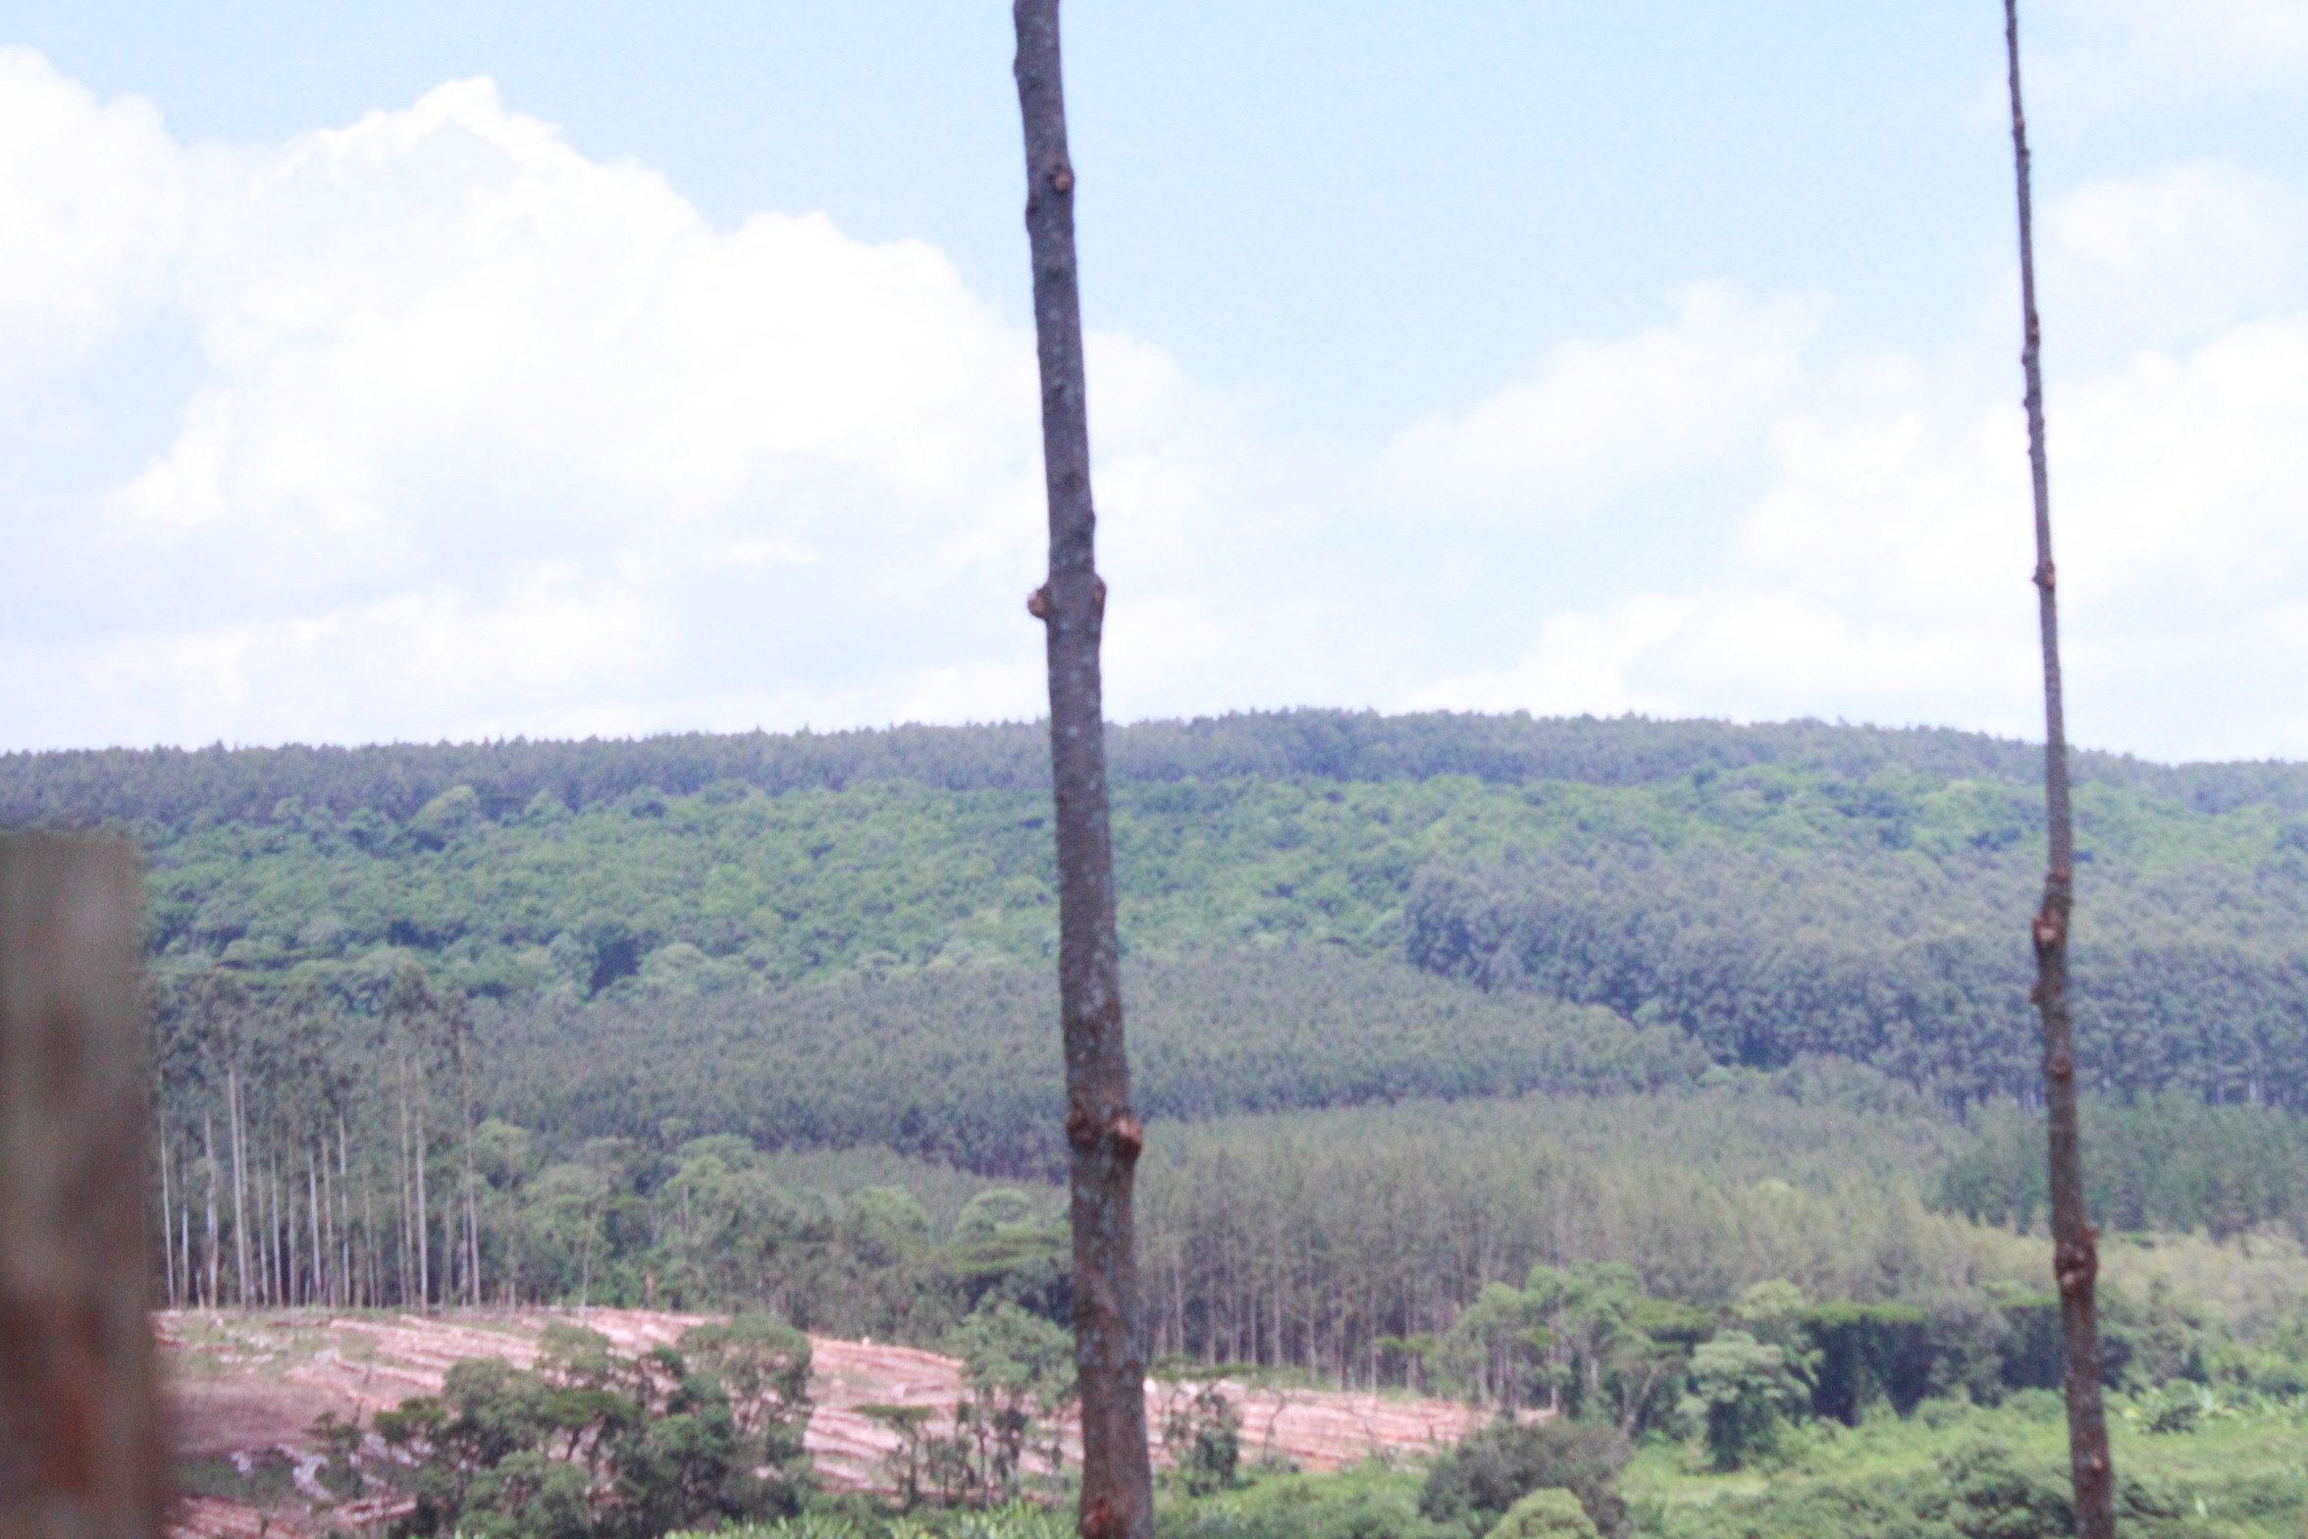
Figure 1. A picture of Cerengoni forest where the study was carried out.

Study Population
Cerengoni forest is in Nandi East Nandi County Kenya which borders the Northern Tinderet part of Tinderet forest. This forest boarders the two counties of Uasin Gishu and Nandi. There was a worrying concern from the Kenya Forest Service officers in Nandi County, who have been protecting this forest about the plantations of these two tree species of Cupressus lusitanica and Pinus patula, as a result of debarking activities they observed that were conducted by animals that have been ongoing for so long. As a result, an assessment of this forest ecosystem had to be conducted to determine which species of animals debark these trees, and secondly, to find out to what extent the debarking processes had affected the two tree species types. The two tree species being exotic, are a special resource to the ecosystem biodiversity hence creates concerns to not only the Kenya Forestry Service in Nandi County, but also to the entire community of Cerengoni. Biodiversity is essential and any slight loss of a species experienced to the ecosystem, creates an imbalance to the entire ecosystem. This study focused on 163 trees of Pinus patula tree plantations in sub compartment 1A, and 129 trees of Cupressus lusitanica tree species of sub compartment 2G of Cerengoni forest block bringing a total of 292 sampled trees out of the total area ha of 93.7, and the entire population of monkeys in the Cerengoni forest.

Sample Size and Sampling Techniques
Fieldwork commenced in February 2021, and continued till May 2021. Three days a week, three weeks a month was the average period spent on the forest compartments during these entire 4 months. The two-forest sub compartment were selected in December 2020, as Cerengoni 1A of Pinus patula and Cerengoni 2G of Cupressus lusitanica with extensive debarking and successful distribution. Field work consisted of four parts as follows;

I. Field Survey based on Ranging Behavior and Species Identification
A random sampling technique was used where a troop population of monkeys was established, as they were crossing the observation paths (Chapman, Chapman and Wrangham, 2005). The researcher and the forest assistants, would arrive at the study site at Cerengoni forest and proceed to the riverine areas of the forest for location of the monkeys. Fieldwork relied on the location and observation of monkey troops in the ground of research. The Kenya Forest assistants located monkeys by use of GPS and visual and auditory cues, a form of method used by the endemic people who inhabit in this forest (majorly the “Ndorobo people”) to locate primates in the forest. All this information helped in collecting data on species identification. The researcher with the help of research assistants, interviewed people in village close to the forest and also staff from the Kenya forestry Service in Nandi County, asking them to describe the primates they see in the forest and to mimic their calls. The researcher showed them photographs of different species afterwards to confirm their identifications. The researcher gathered the information about the presence of monkeys, in Cerengoni. The researcher and research assistants walked slowly and quietly along the paths at 1km/hour, for an average of 5 hours per day. The walking was back and forth to note any visible or acoustic sign of the presence of monkeys. This was done early in the morning at 07:00H to 12:00H. When a group was detected, the researcher and research assistants stayed with the group for observation as long as possible from a distance. The researcher used Kingdon and Largen, (1997) (An African field guide book for mammals) for the identification of species of the monkeys.
As a result of control operations in the study compartments, the behavior of monkey in the forests did not range. Therefore, observational information was systematically obtained, giving a first-hand information. The Kernel Worton Method (1989), was implemented to help in studying the different range of behaviors of monkeys in their groups as animals or as individuals. The home ranges were between 12 ha and 11ha using 95% minimum convex polygons, and home range overlap in the entire 4 months of the study. Daily path lengths were between 1.03km and 1.2km. Fruit was the most commonly consumed dietary item followed by insects and leaves, and some plant resources were identified. This helped in gathering of data to assess the distribution of these animals.

II. Descriptive Survey based on Feeding Behavior
The researcher gathered information on the monkeys eating through first-hand data. This was a descriptive design method used whereby, the monkeys could be observed by use of binoculars and from what they ate, data was obtained on that. As a result, the endemic people at the forest were able to give reasons for the monkeys’ debarking of trees.

III. Descriptive Survey based on Monkeys Debarking in Cerengoni Forest
Data on debarking (type, height, age, and frequency) from the two compartments involved was investigated. Furthermore, in the two sampled compartments, all trees were examined. Presence or absence of debarking was recorded on regular data sheets and the following characteristics; Type, height, age, and frequency.

A. Type of Debarking
In this study, the type of debarking referred to classification of debarking based on classes which were used to indicate the extent of debarking of the monkeys in relation to the part of the tree.
Class 1. <50% of the circumference of the bark removed in a single area.
Class 2. >50% of the circumference of the bark removed in a single area.
Class 3. Ringbarked
Class 4. Crown dead
Class 5. Branches broken
Class 6. Debarking healed

B. Height of Debarking
In this study, the height of debarking referred to classification of debarking based on extent of debarking by the monkeys up the tree.
- 0-0.5m
- 0.5m-1.0m
- 1.0m-1.5m
- 1.5m-2.0m
- 2.0m-3.0m
- >3.0m

C. Age of Debarking
The age of debarking referred to classification of debarking based on how recent debarking was made.
- New debarking
- Old debarking

D. Frequency of Debarking
The frequency of debarking referred to classification of debarking based on how often debarking was made.
- Once
- More than once
IV. Field Survey based on Belt Transect Sampling
The researcher sampled ¼ of each forest block compartment. Cerengoni A1 had a total area of 47.8 Ha, while Cerengoni 2G had a total area of 45.9Ha where ¼ of the two areas was approximately 11Ha which is equivalent to 44,515M². This is a representation of approximation of (210M by 210M). From the 210M², the researcher used a belt transect method at (50M by 50M) on the diagonal of the 210M² to divide the sampled area into 6 plots of (50M by 50M). These plots were used as the sample plots where trees in these plots were counted and used as a representative of the entire compartment. In each of the two sub-compartments forest blocks, the belt transects were laid out systematically over the area facing the Nandi-East diagonal direction starting from the forest edge to the other end of the forest boundary. The forest edge was a distance of 100M. A space of 10M was the distance between one plot to the other plot. Sampling was done by moving between one belt transect plot to the other and in each plot, data on trees were recorded in terms of Type, Age, Height, and Frequency.

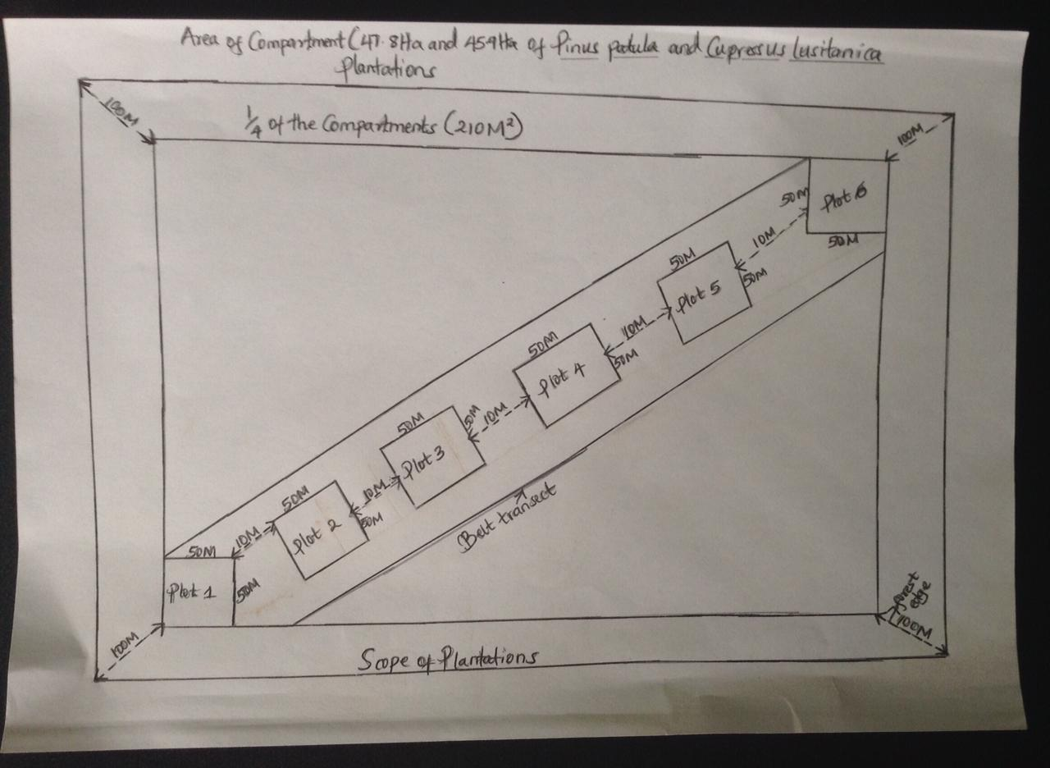
Figure 2. A Sketch diagram illustrating a belt transect layout.

Research Instruments
The researcher used first-hand report from the KFS forest assistants to obtain information concerning the losses of the tree species of Cupressus and Pinus. Belt transects were laid out during the field survey by use of a linear tape to help in measurements collection for the study sites. A GPS device was used in the study to record the altitude/elevation of the two sub compartments of the forest plantations and also in location of the monkeys. The radio tracking device was used by the KFS’s assistants to sense the dangers of any wild animals in the forest. A Canon camera was used to take pictures of the monkeys while the binoculars, and the Mammal study guide book were used to identify the pictures of the monkey species. The Suunto Clinometer was used to measure the heights of the trees in the study sample plot areas, while the diameter tape was used to measure the DBH diameter of the trees sampled for the study. Lastly, raw data was recorded on the paper fullscaps.

Data Collection Procedures
Data collection involved obtaining permission from the relevant authorities. A letter of introduction was obtained from the Director of Graduate Studies, University of Eastern Africa, Baraton, then followed with a letter from National Science for Commission and Innovation (NACOSTI), and a letter from the Ministry of Interior and Innovation of the County Government of Nandi which a copy was sent to the station Director of Cerengoni Forest station to the study site.
Data was collected from the study area along belt transects plots. Research participants moved in each transects (plots) to sample both the 2 sub-compartments tree species of Pinus and Cupressus. Once a tree was sampled, (DBH), the measurements of the tree heights sand diameters were recorded. Feeding behavior of monkeys was obtained from first- hand information by the endemic people in the forest.
Monkey species identification was done in the research ground by the lead researcher
through the help of the KFS assistants, and the endemic people who inhabited the forest. The lead researcher used the Kingdon and Largen, (1977), (An African field guide book for mammals) for the identification of the species name. For the study of different range of behaviors of monkeys in their groups as animals or as individuals, the researcher and her assistants implemented a method known as the Kernel Worton Method (1989).

Data Analysis Procedures
Descriptive statistics was used to analyze the extent of Cupressus lusitanica and Pinus patula as a result of debarking. Frequencies, means, and percentages, were tabulated to describe the debarking of the trees based on type, height and age. Findings obtained from debarked trees, was presented through tables (Shannon, 2000). The data was analyzed using Microsoft excel version 2016 for windows 10, and SPSS statistical software tool version 25 to test on the significant difference between the total number of trees in the forest, and the total debarked trees by use of Pearson’s Chi-square test method. To test on the significance in mean difference of diameter and heights, One- Sample T-test statistics was used. Independent T-test was used to test on the significant mean difference between the total percentages of debarked Cupressus lusitanica and Pinus patula trees.

Ethical Considerations
Clearance for the study was sought from (UEAB) University of Eastern Africa Baraton Review Ethics Committee graduate studies office, National Commission for Science, Technology and Innovation (NACOSTI), Ministry of Interior and Coordination of National Government Nandi County office, and permission obtained from the Director of the Kenya Forestry Service of Nandi County Cerengoni offices.

CHAPTER FOUR

PRESENTATION OF FINDINGS, ANALYSIS AND INTERPRETATION

Introduction
This chapter presents the data analysis, methods of data presentation, interpretation, and discussion. The data has been presented using appropriate tables and figures for easy interpretation. The data analysis and interpretation were done based on the objectives and hypothesis of this study.
This section discusses the incidence and degree of debarking at Cerengoni forest. It gave an insight to the patterns of debarking in each compartment and to a single tree. This section further demonstrated the situation as it was on each compartment at that particular time. In addition, there was no any other information on tree debarking available at the Nandi County offices.
To investigate debarking at the Cerengoni forest, data was extracted from two compartments (Cerengoni 1A and Cerengoni 2G). There was an intensive sampling of the two compartments through inspection of every tree in every 3rd row (this means, study conducted as from the edge of the forest to the study site where trees were populated with the distance measured). Incidence of debarking, and the following features were recorded.

Research Objective 1; Measuring the extent of tree species (Cupressus lusitanica and Pinus patula) debarking by monkeys in Cerengoni Forest.
A total of 292 species of Pinus and Cupressus were sampled. DBH (Diameter and Heights) of debarked trees in each of the two sub-compartments forests measurements were recorded, in (Table 1, 3, 4, and 5) and One- Sample Statistics T-Test analysis, was carried out in (Table 2, 7, and 8). Data on the extent of Cupressus lusitanica and Pinus patula debarking by monkeys was obtained in form of table 9. Table 10 and 11, were on the descriptive statistics on the significant difference between the total number of trees and the total debarked trees, and the Independent T-Test. Lastly, table 12 was on debarking based on type, height, and age of trees.

Table 1. Showing the DBH Diameter (cm) of Debarked area of Pinus patula.
Codes | Plot 1 | Plot 2 | Plot 3 | Plot 4 | Plot 5 | Plot 6
1 | 22.2 | 13.6 | 25 | 44.8 | 28.8 | 9.2
2 | 27.3 | 10.4 | 19.3 | 24.2 | 18.8 | 5
3 | 11.5 | 16 | 8.8 | 7.8 | 27.4 | 35.1
4 | 8.3 | 35.1 | 18 | 28.2 | 24.5 | 16.6
5 | 12.6 | 10.6 | 29.2 | 35 | 31.3 | 20.5
6 | 5.8 | 6.8 | 13.8 | 4.6 |  | 22.7
7 | 7.6 | 29.6 | 24.6 | 4.7 |  | 14.4
8 | 23.5 | 9.4 | 16.5 | 21.5 |  | 22.2
9 | 16.7 | 9.8 | 25.3 | 25.6 |  | 17.8
10 | 11.1 | 11.6 | 20.8 | 24.8 |  | 31.2
11 | 15.2 | 13.5 | 8.7 | 15.4 |  | 10
12 | 21.3 | 15.8 | 25.7 | 32.7 |  | 16.5
13 | 14.7 | 14 | 17 |  |  | 14.8
14 | 9.7 | 19.2 | 14.7 |  |  | 31.8
15 | 11.6 | 24 | 8.8 |  |  | 17.8
16 | 10.8 | 5 | 8.4 |  |  | 15.4
17 | 12.7 | 23.2 | 22.4 |  |  | 14.8
18 | 13 | 5.5 | 14.6 |  |  | 11
19 | 16.8 | 22.2 | 32.8 |  |  | 30.4
20 | 7.7 | 14.8 | 13.3 |  |  | 14
21 | 20.4 | 14 | 10 |  |  | 10.5
22 | 19.3 | 21.29 | 14.8 |  |  | 14.5
23 | 43.9 | 28.7 | 8.4 |  |  | 26
24 | 6.5 | 6.1 | 21.8 |  |  | 17.4
25 | 76 | 4.1 | 18.2 |  |  | 15.4
26 | 14 | 7 | 10 |  |  | 10.5
27 | 6.7 | 24.8 | 25.5 |  |  | 16.5
28 | 35.2 | 10.4 | 12.6 |  |  | 13.3
29 | 9.9 | 4.5 | 10.8 |  |  | 27.3
30 | 5.7 | 25.2 | 23.1 |  |  | 11.8
31 | 10.8 | 5.5 | 22.4 |  |  | 22.2
32 | 36.8 | 26.8 | 13.3
33 | 25.2 |  | 20.2
34 | 37.1
34 | 11.8
36 | 7.4
37 | 9.2
38 | 5.8
39 | 6.5
40 | 12.8
41 | 13.4
42 | 26.6
43 | 16.2

Table 2. One-Sample T-Test of DBH Diameter (cm) of Debarked area of Pinus patula trees.
T-Test
One-Sample Statistics
 | N | Mean | Std. Deviation | Std. Error Mean
VAR00001 (Plot 1) | 43 | 17.1465 | 13.10615 | 1.99867
VAR00002 (Plot 2) | 32 | 15.2653 | 8.53598 | 1.50896
VAR00003 (Plot 3) | 33 | 17.5394 | 6.70657 | 1.16746
VAR00004 (Plot 4) | 12 | 22.4417 | 12.47750 | 3.60195
VAR00005 (Plot 5) | 5 | 26.1600 | 4.79197 | 2.14304
VAR00006 (Plot 6) | 31 | 17.9548 | 7.39251 | 1.32773

One-Sample Test
 | Test Value = 0
 | t | df | Sig. (2-tailed) | Mean Difference | 95% Confidence Interval of the Difference
 |  |  |  |  | Lower | Upper
VAR00001(Plot 1) | 8.579 | 42 | .000 | 17.14651 | 13.1130 | 21.1800
VAR00002 (Plot 2) | 10.116 | 31 | .000 | 15.26531 | 12.1878 | 18.3429
VAR00003 (Plot 3) | 15.023 | 32 | .000 | 17.53939 | 15.1613 | 19.9174
VAR00004 (Plot 4) | 6.230 | 11 | .000 | 22.44167 | 14.5138 | 30.3695
VAR00005 (Plot 5) | 12.207 | 4 | .000 | 26.16000 | 20.2100 | 32.1100
VAR00006 (Plot 6) | 13.523 | 30 | .000 | 17.95484 | 15.2432 | 20.6664

Table 3. Showing the DBH Diameter (cm) of Debarked area of Cupressus lusitanica.
Codes | Plot 1 | Plot 2 | Plot 3 | Plot 4 | Plot 5 | Plot 6
1 | 25.6 | 28 | 29 | 33.5 | 22.3 | 19.9
2 | 16.8 | 24 | 18.8 | 24 | 15 | 27.2
3 | 20.2 | 32 | 24.5 | 19 | 26.4 | 19.2
4 | 17 | 25.8 | 26.8 | 24 | 18.3 | 13.5
5 | 27 | 20.6 | 17.5 | 22 | 26.3 | 21
6 | 15.1 | 20 | 0.4 | 15.8 | 25.7 | 17
7 | 18 | 18 | 22 | 19.9 | 19.2 | 21.5
8 | 18.2 | 29 | 24 | 31 | 10.2 | 21
9 | 27.3 | 22.5 | 33 | 17.2 | 29 | 30.3
10 | 15.8 | 28 | 17.7 | 24.6 | 10 | 12.1
11 | 25 | 18 | 22.5 | 22 | 13 | 20
12 | 10.1 |  | 33.5 | 5.8 | 7.1 | 14
13 | 15.5 |  | 16.8 | 5 | 15 | 20.8
14 | 17.2 |  | 16.4 | 9.3 | 18.8 | 10.3
15 | 24 |  | 19.5 | 23.8 | 14 | 11.3
16 | 23 |  | 18.3 | 25.8 | 17.2 | 11
17 | 22.8 |  | 29 | 8.5 | 24.7 | 24.5
18 | 10.7 |  | 25 | 12.3 |  | 16.1
19 | 18.3 |  | 42 | 22.8 |  | 22
20 | 13.5 |  | 18 | 6 |  | 20
21 | 22 |  |  | 5.5 |  | 13.1
22 | 23 |  |  | 9.3 |  | 14.7
23 | 27.3 |  |  | 28.8 |  | 27.3
24 | 32.5 |  |  | 5.5 |  | 18.5
25 |  |  |  | 24 |  | 21.4
26 |  |  |  |  |  | 17.3
27 |  |  |  |  |  | 16
28 |  |  |  |  |  | 14
29 |  |  |  |  |  | 30
30 |  |  |  |  |  | 27
31 |  |  |  |  |  | 15

Table 4. One- Sample Statistics T-Test of the DBH Diameter (cm) of Cupressus lusitanica.
T-Test

One-Sample Statistics
 | N | Mean | Std. Deviation | Std. Error Mean
VAR00001 (Plot 1) | 24 | 20.2458 | 5.66638 | 1.15664
VAR00002 (Plot 2) | 11 | 24.1727 | 4.75102 | 1.43249
VAR00003 (Plot 3) | 20 | 22.7300 | 8.56099 | 1.91430
VAR00004 (Plot 4) | 25 | 17.8160 | 8.86161 | 1.77232
VAR00005 (Plot 5) | 17 | 18.3647 | 6.54942 | 1.58847
VAR00006 (Plot 6) | 31 | 18.9355 | 5.58191 | 1.00254

One-Sample Test
 | Test Value = 0
 | t | df | Sig. (2-tailed) | Mean Difference | 95% Confidence Interval of the Difference
 |  |  |  |  | Lower | Upper
VAR00001 (Plot 1) | 17.504 | 23 | .000 | 20.24583 | 17.8531 | 22.6385
VAR00002 (Plot 2) | 16.875 | 10 | .000 | 24.17273 | 20.9809 | 27.3645
VAR00003 (Plot 3) | 11.874 | 19 | .000 | 22.73000 | 18.7233 | 26.7367
VAR00004 (Plot 4) | 10.052 | 24 | .000 | 17.81600 | 14.1581 | 21.4739
VAR00005 (Plot 5) | 11.561 | 16 | .000 | 18.36471 | 14.9973 | 21.7321
VAR00006 (Plot 6) | 18.888 | 30 | .000 | 18.93548 | 16.8880 | 20.9829

Interpretation of Table 1- 4 above and Discussion.
From the study carried out, it was found out that the diameter of trees greatly played a major significance in the debarking activities of these trees. The study sampled 156 trees in the entire Pinus patula tree species compartments in table 1. One Sample T-test carried out in table 2 above on DBH Diameter in cm of Pinus patula trees and it showed that the highest diameter difference of Pinus patula species was 42 and this was in plot 5 trees, while the lowest diameter difference was 4 and this was in plot 5 trees. The mean diameter of trees in Pinus plantations, varied considerably. For example, the highest recorded mean difference was in plot 5 trees which was 26.16, while the lowest mean difference was in plot 2 trees which was 15.25. From the compartments of Cupressus lusitanica plantations in table 3 above, the study sampled 128 trees for DBH Diameter in cm. One Sample T- test was carried out as shown in table 4 above, and the highest diameter difference was 30 which was in plot 6 trees, while the lowest mean difference was 10 which was in plot 2 trees. The mean diameter of trees in Cupressus plantations, varied considerably. For example, the highest recorded mean difference was in plot 2 trees which was 24.17, while the lowest mean difference was in plot 4 trees which was 17.81. In the case of Cupressus lusitanica plantations, most debarking was thicky girdled and this happened at the crown. The vervet monkeys and the sykes monkey species preferred thick, and huge trees from both of the tree species. This finding is further supported by Yiming et al., (2000) who found out that monkeys showed preference for older forest trees. The mature stem barks provides the most thick moist and nutrient-rich living tissue compared to young ones (Ross, 2004). A study carried in South Africa on the relationship between bark thickness and diameter at breast height for six species used medicinally, it was found out that Bark thickness generally increases with stem age and diameter (Williams et al., 2007). This is true also in this study on the highest diameter recorded of Pinus patula tree. The tree was found out to be thick, old in age, and the debarking was so intense at the highest region of the tree.

Table 5. DBH Heights of debarked Pinus patula in meters.
Codes | Plot 1 | Plot 2 | Plot 3 | Plot 4 | Plot 5 | Plot 6
1 | 17.5 | 5 | 14.8 | 16.5 | 11.5 | 17
2 | 9.5 | 13 | 9 | 13 | 13.5 | 17
3 | 11 | 12.4 | 15 | 16 | 12 | 12
4 | 14.3 | 4 | 15 | 15.3 | 7 | 18
5 | 16 | 9 | 16.2 | 16.5 | 14 | 17
6 | 17 | 16.4 | 15.2 | 14.5 |  | 17.2
7 | 12.2 | 17.5 | 15 | 13.5 |  | 12.7
8 | 14 | 16.5 | 17.7 | 17.6 |  | 14.2
9 | 14 | 11 | 18.8 | 9.5 |  | 14
10 | 13.8 | 17.5 | 20 | 13.4 |  | 17

Table 6. DBH Heights of debarked Cupressus lusitanica in meters.
Codes | Plot 1 | Plot 2 | Plot 3 | Plot 4 | Plot 5 | Plot 6
1 | 16.5 | 15.5 | 15 | 14.1 | 8.8 | 13
2 | 14.5 | 12.8 | 16.1 | 12.5 | 12.8 | 13.7
3 | 14 | 15.5 | 14.3 | 13.6 | 9.8 | 14
4 | 15 | 12.5 | 8.2 | 9 | 14.5 | 13
5 | 14 | 11.2 | 16 | 7 | 12 | 11.6
6 | 14.5 | 9.8 | 15.1 | 13 | 13.3 | 16
7 | 14.5 | 12.6 | 10.2 | 13.5 | 16.5 | 13.9
8 | 13.8 | 5 | 11 | 15.8 | 16 | 14.9
9 | 11.2 | 11.6 | 12 | 17 | 3 | 14.8
10 | 13.5 | 11.6 | 11 | 14.2 | 4.5 | 13.9
11 |  | 16

Table 7. One- Sample Statistics T-Test of the DBH Heights of debarked Pinus patula in meters.
T-Test

One-Sample Statistics
 | N | Mean | Std. Deviation | Std. Error Mean
VAR00001(Plot 1) | 10 | 13.9300 | 2.53467 | .80153
VAR00002 (Plot 2) | 10 | 12.2300 | 4.98599 | 1.57671
VAR00003 (Plot 3) | 10 | 15.6700 | 2.97697 | .94140
VAR00004 (Plot 4) | 10 | 14.5800 | 2.35457 | .74458
VAR00005 (Plot 5) | 5 | 11.6000 | 2.77038 | 1.23895
VAR00006 (Plot 6) | 10 | 15.6100 | 2.16151 | .68353

One-Sample Test
 | Test Value = 0
 | t | df | Sig. (2-tailed) | Mean Difference | 95% Confidence Interval of the Difference
 |  |  |  |  | Lower | Upper
VAR00001 (Plot 1) | 17.379 | 9 | .000 | 13.93000 | 12.1168 | 15.7432
VAR00002 (Plot 2) | 7.757 | 9 | .000 | 12.23000 | 8.6632 | 15.7968
VAR00003 (Plot 3) | 16.645 | 9 | .000 | 15.67000 | 13.5404 | 17.7996
VAR00004 (Plot 4) | 19.581 | 9 | .000 | 14.58000 | 12.8956 | 16.2644
VAR00005 (Plot 5) | 9.363 | 4 | .001 | 11.60000 | 8.1601 | 15.0399
VAR00006 (Plot 6) | 22.837 | 9 | .000 | 15.61000 | 14.0638 | 17.1562

Table 8. One -Sample T-Tests of the DBH Heights of debarked Cupressus lusitanica in meters.
T-Test

One-Sample Statistics
 | N | Mean | Std. Deviation | Std. Error Mean
VAR00001 (Plot 1) | 10 | 14.1500 | 1.32937 | .42038
VAR00002 (Plot 2) | 11 | 12.1909 | 3.10079 | .93492
VAR00003 (Plot 3) | 10 | 12.8900 | 2.75820 | .87222
VAR00004 (Plot 4) | 10 | 12.9700 | 2.96912 | .93892
VAR00005 (Plot 5) | 10 | 11.1200 | 4.58762 | 1.45073
VAR00006 (Plot 6) | 10 | 13.8800 | 1.20996 | .38262

One-Sample Test
 | Test Value = 0
 | t | df | Sig. (2-tailed) | Mean Difference | 95% Confidence Interval of the Difference
 |  |  |  |  | Lower | Upper
VAR00001 (Plot 1) | 33.660 | 9 | .000 | 14.15000 | 13.1990 | 15.1010
VAR00002 (Plot 2) | 13.039 | 10 | .000 | 12.19091 | 10.1078 | 14.2740
VAR00003 (Plot 3) | 14.778 | 9 | .000 | 12.89000 | 10.9169 | 14.8631
VAR00004 (Plot 4) | 13.814 | 9 | .000 | 12.97000 | 10.8460 | 15.0940
VAR00005 (Plot 5) | 7.665 | 9 | .000 | 11.12000 | 7.8382 | 14.4018
VAR00006 (Plot 6) | 36.276 | 9 | .000 | 13.88000 | 13.0144 | 14.7456

Interpretation of Table 5- 8 above and Discussion.
In table 5 above, the study sampled 55 trees of Pinus patula plantation on DBH heights in meters. One Sample T- test was carried out as shown in table 7 above for Pinus patula DBH Height in meters, and the highest height difference was 9 which was recorded in plots 1, 2, 3, 4, and 6 trees. The lowest difference in height was 4, which was in plot 4 trees. The mean height difference of trees in Pinus plantations, varied considerably. For example, the highest recorded mean difference was in plot 3 trees which was 15.67, while the lowest mean difference was in plot 5 trees which was 11.60. In table 6 above in Cupressus lusitanica plantations, 61 trees were sampled. One Sample T- test was carried out as shown in table 8 above for DBH Height, and the highest height difference was 10 and this was in plot 2 trees while the lowest height difference was 9 which was in plots 1, 3, 4, 5, and 6 trees. The mean heights of trees in Cupressus plantations, varied considerably. For example, the highest recorded mean difference was in plot 1 trees which was 15.15, while the lowest mean difference was in plot 5 trees which was 11.12. In this case, as shown in table 5, and 6, the taller the tree height, the higher the debarking occurrence at the upper crown and vice versa. The fact that this portion occupied the upper canopy where monkeys prefer to stay, might have been the major cause of intense debarking on this part of the tree trunks. Ross (2004), further found out that in the rain forest of Peru, the white fronted capuchin and brown capuchin monkeys preferred to live on the upper canopy spending about 80% of the daylight moving through the forest debarking trees. In the case of Cupressus lusitanica species, when debarking occurred at the middle trunk, the tree died. Longonje et al., (2007) in a study in Kibale National Park, Uganda, found significant differences between the age categories of the bark, between the number of the barks eaten and those not eaten by the Colobus Spp. They also found significant differences between the lower, middle and upper branches in percentage and the mean number of bark samples was positively correlated to the percentage damage. Unlike the Pinus patula species where when debarking occurred, the tree healed, debarking in Cupressus lusitanica species was different.

Table 9. Trees Debarked at Cerengoni Forest.
Comparments | Species | Age | Total Area (Ha) | Area Sampled (Ha) | Sampled Plots | Trees | Debarked | Percentage
Cerengoni1A | Pinus patula | 27 years | 47.8 | 11 | Plot 1 | 43 | 11 | 25.60%
 |  |  |  |  | Plot 2 | 32 | 12 | 37.50%
 |  |  |  |  | Plot 3 | 34 | 12 | 35.30%
 |  |  |  |  | Plot 4 | 12 | 3 | 25%
 |  |  |  |  | Plot 5 | 10 | 4 | 40%
 |  |  |  |  | Plot 6 | 32 | 10 | 31.25%
Total |  |  |  |  |  | 163 | 52 | 31.9%
Cerengoni 2G | Cupressus lusitanica | 16 years | 45.9 | 11 | Plot 1 | 24 | 16 | 66.70%
 |  |  |  |  | Plot 2 | 11 | 9 | 81.80%
 |  |  |  |  | Plot 3 | 20 | 15 | 75%
 |  |  |  |  | Plot 4 | 25 | 16 | 64%
 |  |  |  |  | Plot 5 | 18 | 18 | 100%
 |  |  |  |  | Plot 6 | 31 | 20 | 64.50%
Total |  |  |  |  |  | 129 | 94 | 72.8%

Interpretation of Table 9 above and Discussion.
In reference to table 9 above, the average total percentage of the sampled Pinus patula trees debarked from Cerengoni1A compartment was 31.9% out of the whole 11 ha sampled area. This percentage comes by dividing the total number of debarked trees which is 52 by the total number of trees which is 163, then multiply the sum by 100%. The table also shows that the total percentage of sampled Cupressus lusitanica trees debarked from Cerengoni 2G compartment was 72.8% out of the whole 11 ha sampled area. This percentage comes by dividing the average total number of debarked trees which is 94 by the total number of trees which is 129, then multiply the sum by 100%. There is a statistically significant difference in the level of debarking between Pinus patula and Cupressus lusitanica (P=0.00<0.05) or p<0.0001. Therefore, it can be inferred that monkeys prefer the barks of Cupressus lusitanica. However, Maganga and Wright (2008), while studying bark-stripping of forest planations by blue-monkeys in Tanzanian forest plantations asserts that, 79.5% of Cupressus lusitanica was stripped in comparison with 88% of Pinus patula. This findings revealed contrary findings to the present study based on my research results obtained. This therefore means that the rate at which Cupressus lusitanica species are affected, as a result of debarking in the studies conducted, are higher than those of the Pinus patula tree species. This could be, different monkey species prefer debarking different tree species at different levels.
Table 10. Descriptive statistics on the significant Difference between the total number of trees and the total debarked trees.
Chi-Square Tests
 | Value | df | Asymptotic Significance (2-sided)
Pearson Chi-Square | 12.000ª | 10 | .285
Likelihood Ratio | 16.636 | 10 | .083
Linear-by-Linear Association | .884 | 1 | .347
N of Valid Cases | 12

Interpretation of Table 10 above and Discussion.
To find out the difference between the total number of trees and the total debarked trees, the researcher used Pearson's chi-square test of association. This was used to discover if there is a relationship between the two that is, (the total number of trees, and the total number of debarked trees).
From the table 10 above, the study was interested in the results of the Pearson Chi-Square row. From the table above, p = .285. This tells that there is no statistically significant difference between type of trees and debarked trees that is, both total trees and debarked trees do not differ significantly meaning that the debarking of trees at the periphery of the plot and its center is independent of that location. Chirchir et al., (2018), from studies on the “Impacts of forest disturbance on food trees of Colubus angolensis in Kibonge forest Kenya”, data analyzed was by Chi square tests and SPSS statistical tool which infers with this specific studies.
Table 11. Descriptive Statistics on the Significant difference between the total percentages of debarked Cupressus lusitanica and Pinus patula trees.
Unpaired t-test/Independent t-test (compare two data means percentages)
Col A (Pinus)
Vs
Col B (Cupressus)
Statistic
Mean ± sd of Col A (Pinus) | 32.450 ± 6.235
Mean ± sd of Col B (Cupressus) | 75.333 ± 13.934
Difference of means | -42.883
C.I. (95%) of mean difference | ± 13.885
Lower Range | -56.769
Upper Range | -28.998
T | 6.881
t, critical | 2.228
p value | < 0.0001
Are the means different (p<0.05)? | Yes
One or two-tailed? | Two-tailed
Significance level at 95%

Interpretation of Table 11 above and Discussion.
To find out the mean difference between total percentages of debarked Cupressus lusitanica trees and Pinus patula trees, the researcher used Unpaired t-test/Independence t-test. This was used to determine if there is difference in the percentage means of the two tree species.
From the above findings on table 11, the study was interested in the results of the Un-paired t-test row. p value < 0.0001. This therefore tells that, there is a significant mean difference in the percentages of both Cupressus and Pinus species. The mean difference of Cupressus as we can see from the table above, is higher than that of Pinus. This asserts that, debarking by monkey species in Cupressus trees is higher than that of Pinus trees. Tesfaye et al., (2020), from studies conducted on the “Above ground biomass, growth, and yield for some selected introduced tree species of Cupressus lusitanica, Eucalyptus saligna, and Pinus patula, in the central Highlands of Ethiopia”, showed that the mean difference in the yields, varied significantly among the species whereby the results showed that Cupressus species had the highest aboveground biomass, volume, basal area, while Eucalyptus saligna species had the lowest value. From the findings of this study, there is a mean significant difference in the percentages of both Cupressus and Pinus tree species.
Table 12. Debarking Based on Type, Height, Age, and Frequency.
Compartment | Cerengoni 1A (Pinus patula) | Cerengoni 2G (Cupressus lusitanica)
Trees Debarked in % | 32% | 73%
Frequency of Debarking once in % | 0% | 0%
Frequency of Debarking more than once in % | 21% | 60%
Type of Debarking  Class 1.  Class 2.  Class 3.  Class 4.  Class 5.  Class 6. | 0%  0%  0%  4%  2%  25% | 24%  8%  2%  0%  13%  26%
Height of Debarking  0-0.5m  0.5m-1.0m  1.0m-1.5m  1.5m-2.0m  2.0m-3.0m  >3.0m | 2%  3%  2%  4%  4%  17% | 3%  2%  5%  2%  9%  51%
Age of Debarking  New Debarking  Old Debarking | 0%  32% | 30%  45%

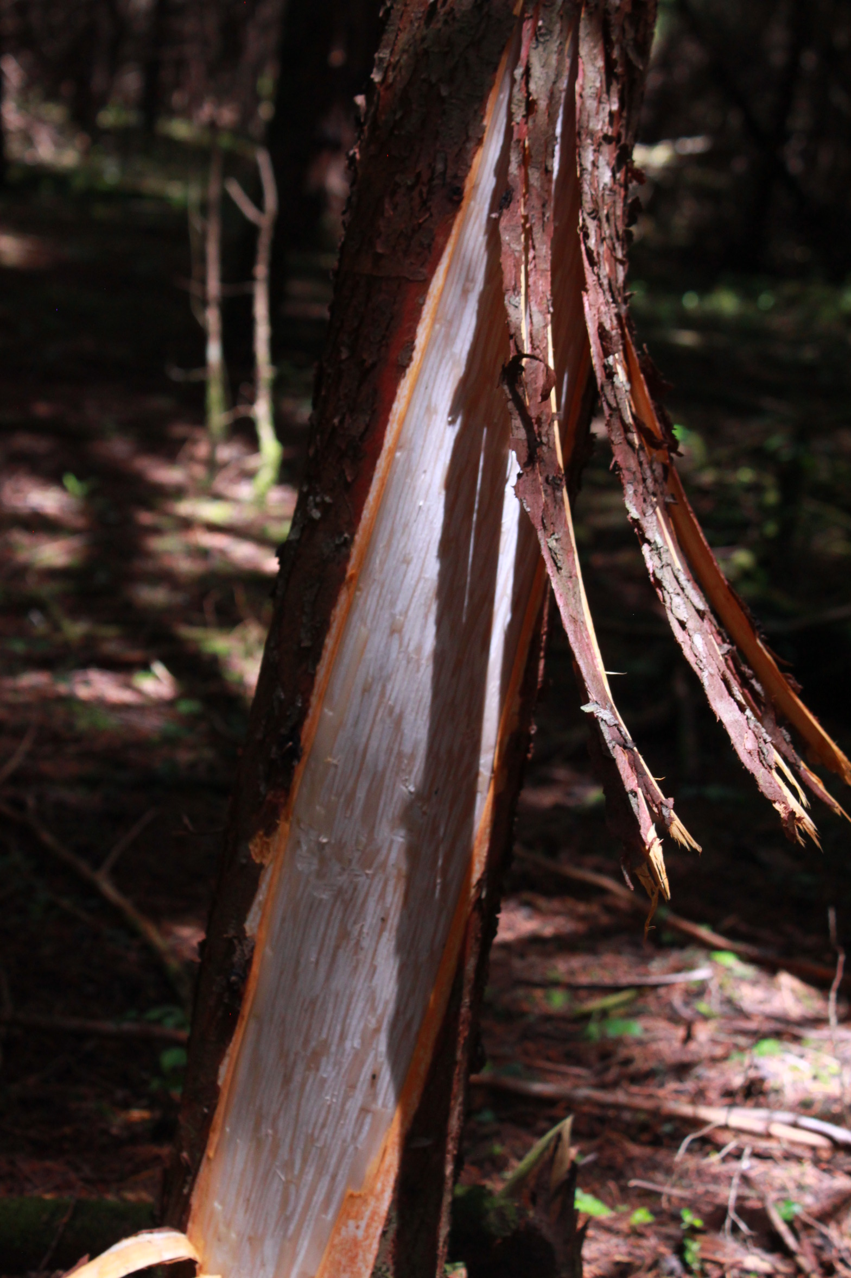Figure 3. Class 1. <50% of the circumference of the bark removed in a single area.

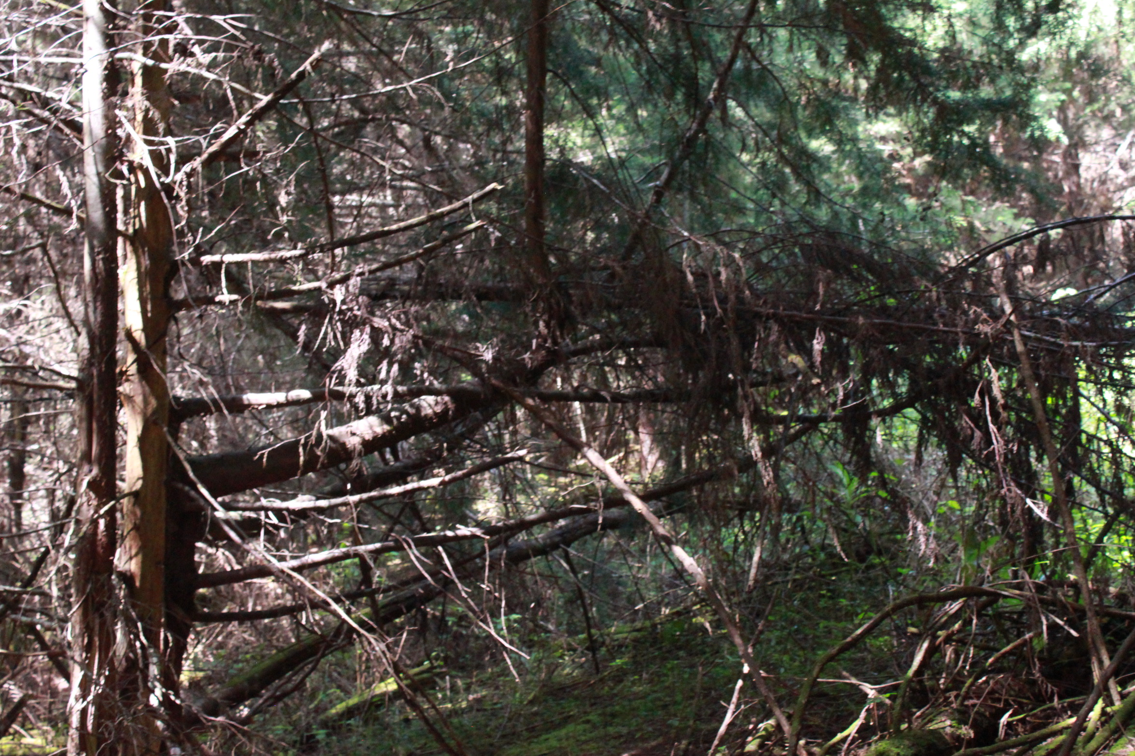
Figure 4. Class 2. >50% of the circumference of the bark removed in a single area.

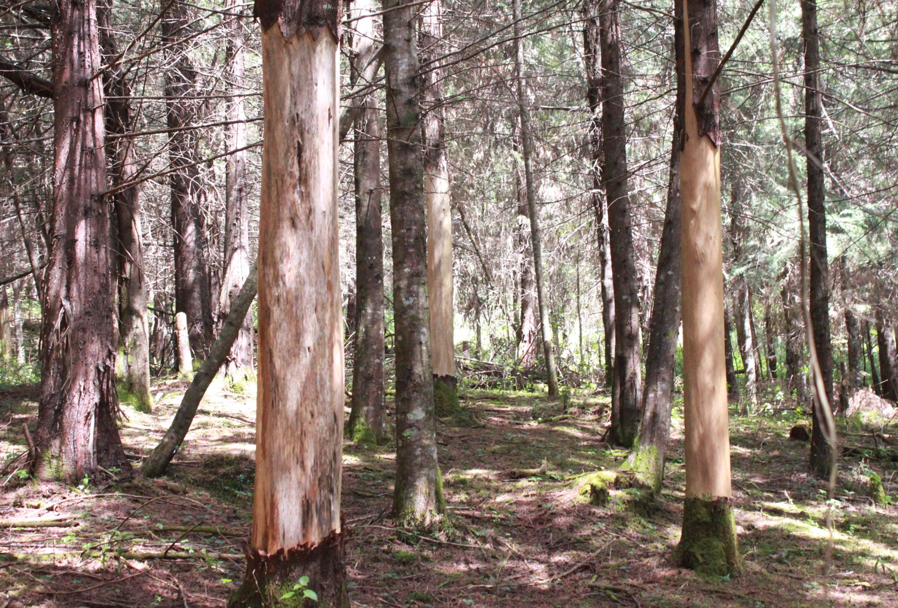
Figure 5. Class 3. Showing Ring Debarked.

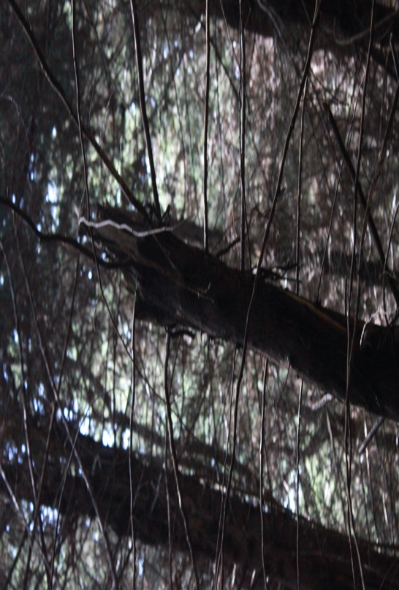
Figure 6. Class 4. Showing debarking of Crown dead.

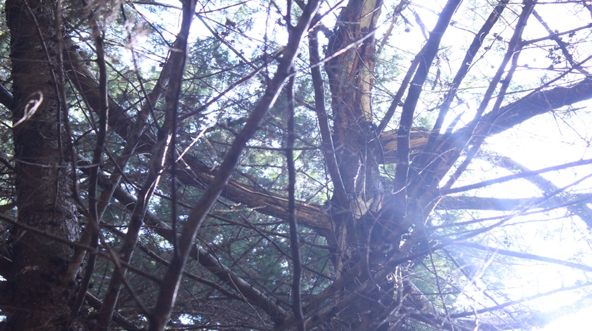
Figure 7. Class 5. Showing branches broken due to debarking.

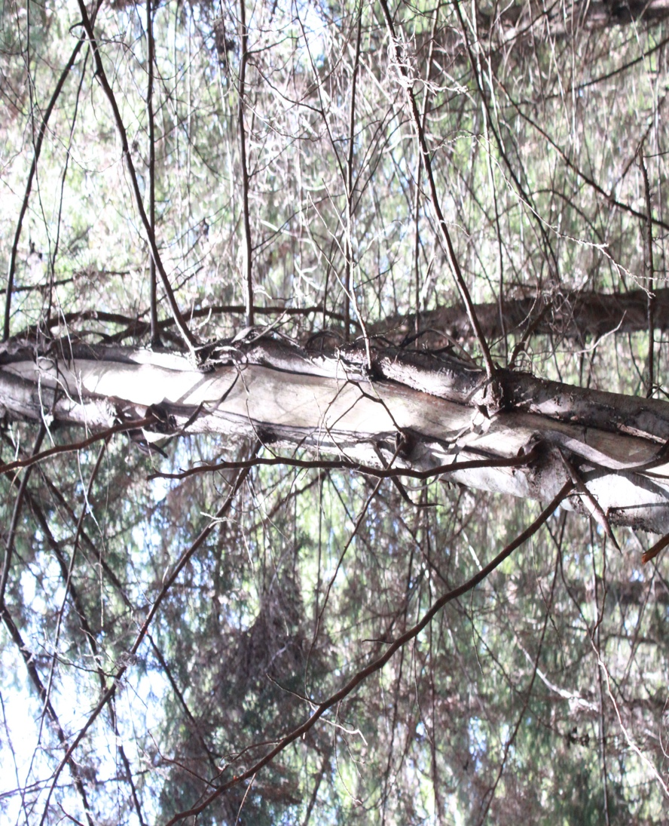
Figure 8. Class 6. Showing healed debarking.

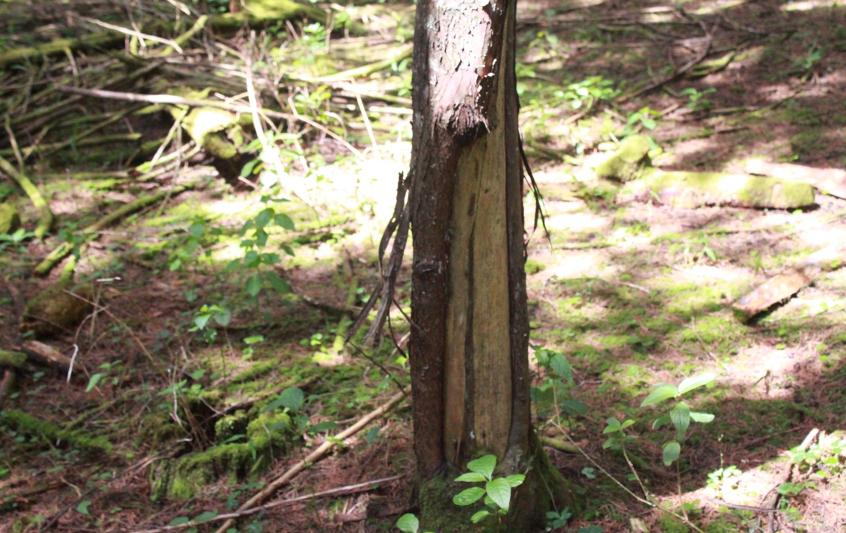
Figure 9. Showing the height of debarking from <3.0 Meters.

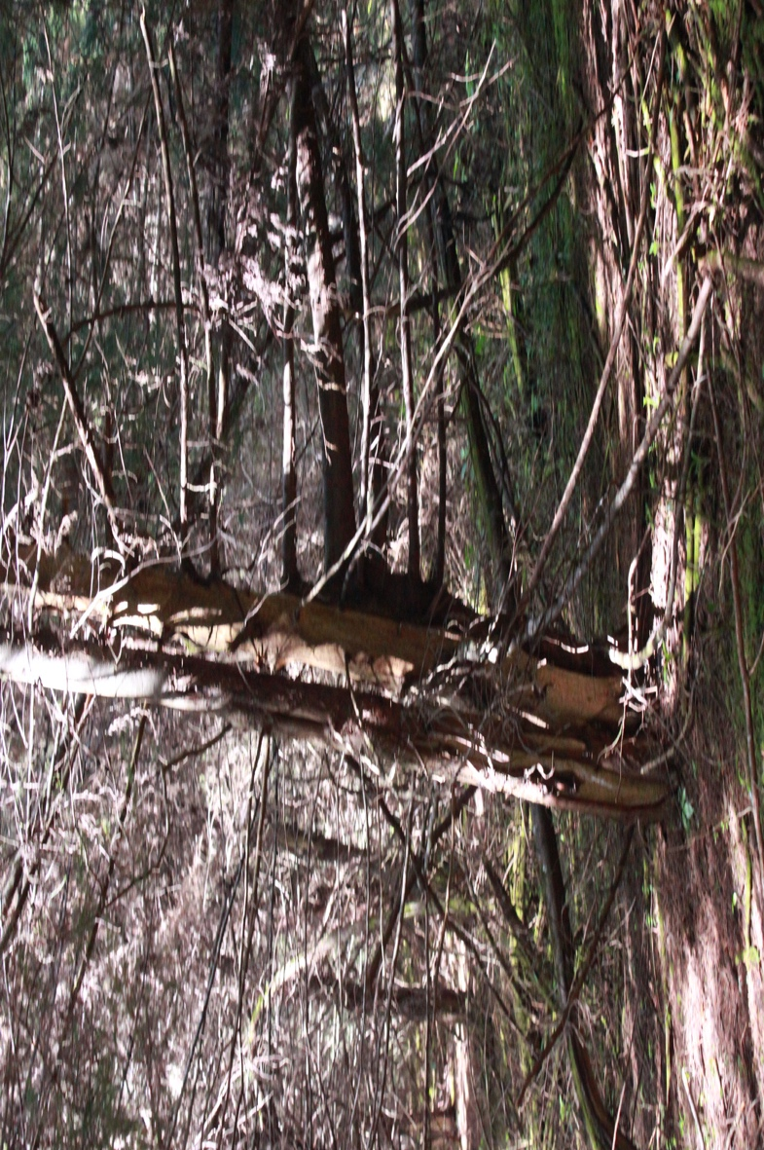
Figure 10. Showing height of debarking >3.0 Meters.

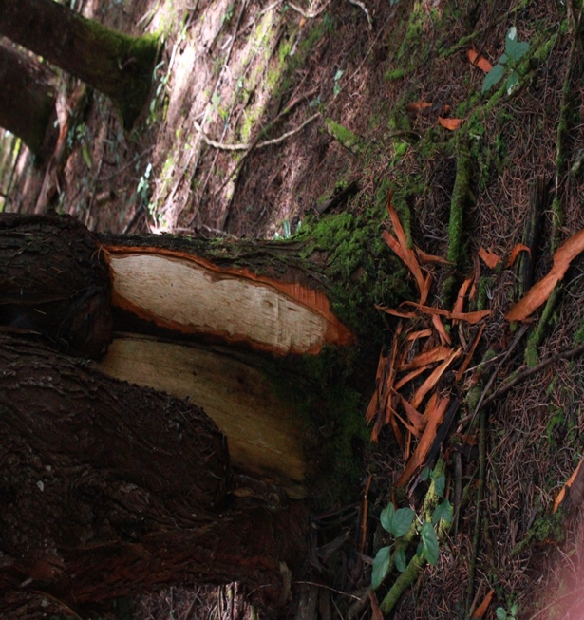
Figure 11. Showing New Debarking of Cupressus lusitanica.

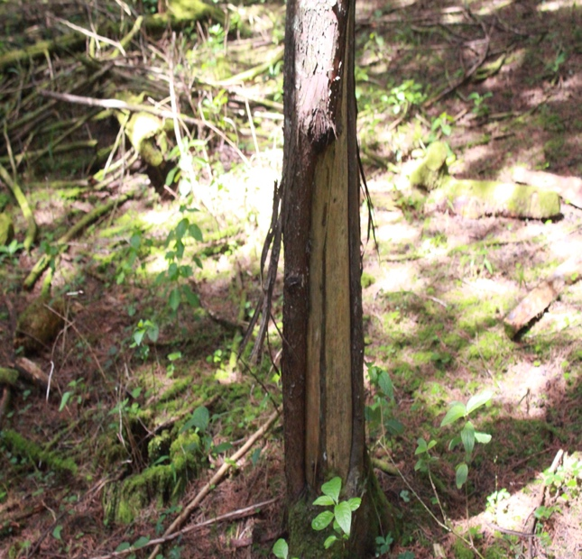
Figure 12. Showing Old Debarking of Pinus patula.

Interpretation Table 12, Figure 3- Figure 12 above, and Discussion.
Table 12 above gives the representation on the type, age, frequency, and age of debarking. As indicated, frequency of debarking made once shows that both Pinus and Cupressus tree species showed 0%, while 21% of the debarked Pinus patula in Cerengoni 1A were debarked more than once while in Cerengoni 2G, 60% of the debarked Cupressus lusitanica were debarked more than once. On the type of debarking, the table indicates that class 1, 2, and 3 debarking were recorded in Cerengoni 2G among the Cupressus lusitanica only. 24% of Cupressus lusitanica were recorded to have class 1 debarking, 8% had class 2 debarking and 2% had class 3 debarking. Class 4 debarking was only recorded in Cerengoni 1A among the Pinus patula where 4% of them were recorded. Cupressus lusitanica of Cerengoni 2G recorded the highest number of class 6 debarking (26%) with Pinus patula of Cerengoni 1A recording only 25% of class 6 debarking. Cupressus lusitanica of Cerengoni 2G recorded the highest number of class 6 debarking (26%) as compared to the Pinus patula of Cerengoni 1A (25%).
Generally, class 6, class 1, class 5 and class 2 debarking were the majority of debarking in Cerengoni forest station. This means that the debarking of trees in this forest station starts from removal of less than 50% of the circumference of the bark, removal of greater than 50% of the circumference of the bark, breaking of branches to healing of the trees.
Based on tree size, height and girth is influenced generally by age and conditions of growth such as soil type, disturbance, and rainfall pattern among others (Mligo et al., 2009). Being that all the blocks experienced relatively similar weather pattern, soil characteristics, and rainfall pattern were probably similar. The variation in height can thus be attributed to age of tree, and human disturbance or both. From table 12 above, Cupressus lusitanica of Cerengoni 2G recorded the highest number of 0-0.5m height of debarking (3%) as compared to the Pinus patula of Cerengoni 1A (2%). Pinus patula of Cerengoni 1A recorded the highest number of 0.5m-1.0m debarking (3%) as compared to Cupressus lusitanica of Cerengoni 2G (2%). Cupressus lusitanica of Cerengoni 2G recorded the highest number of 1.0m-1.5m debarking (5%) as compared to Pinus patula of Cerengoni 1A (2%). Pinus patula of Cerengoni 1A recorded the highest number of 1.5m-2.0m debarking (4%) as compared to Cupressus lusitanica of Cerengoni 2G (2%). Cupressus lusitanica of Cerengoni 2G recorded the highest number of 2.0m-3.0m debarking (9%) as compared to Pinus patula of Cerengoni 1A (4%). Cupressus lusitanica of Cerengoni 2G recorded the highest number of >3.0m debarking (51%) as compared to Pinus patula of Cerengoni 1A (17%). Mutiso et al., (2008), Duncan Multiple Range Test also showed that the most preferred part of the trunk was the upper portion compared to the lower, middle and top. The debarked parts of the stem showed a strong positive Pearson correlation (n = 4, rs = 0.876, p = 0.05) with the height of debarking.
Generally, majority of the debarking in Cerengoni forest station were higher than 3 meters. However, other debarking in this forest station were ranging from 0 m-3 m high.
Mutiso et al., (2016), based on his findings, the test of homogeneity of variance showed that among the three age cohorts of Cupressus lusitanica tested for debarking, >20 years was the most statistically significant age class (P<0.05). From the findings of this study, Pinus patula species existed for 27 years as recorded from the Kenya Forestry Service record inventory books while Cupressus lusitanica recorded an age of 16 years existence in Cerengoni forest. This explained well with how debarking activities occured to all the species of Pinus, as compared to the species of Cupressus. As indicated in table 12 above, Pinus patula of Cerengoni 1A did not record any new debarking as compared to Cupressus lusitanica of Cerengoni 2G which recorded 30% new debarking. 32% of the debarked Pinus patula of Cerengoni 1A were old debarking. Of the debarked Cupressus lusitanica of Cerengoni 2G, 45% were old debarking. Generally, the majority of debarking in the Cerengoni forest station were old debarking as compared to the new debarking.
Research objective 2. Monkey Species Debarking Cupressus lusitanica and Pinus patula in Cerengoni.
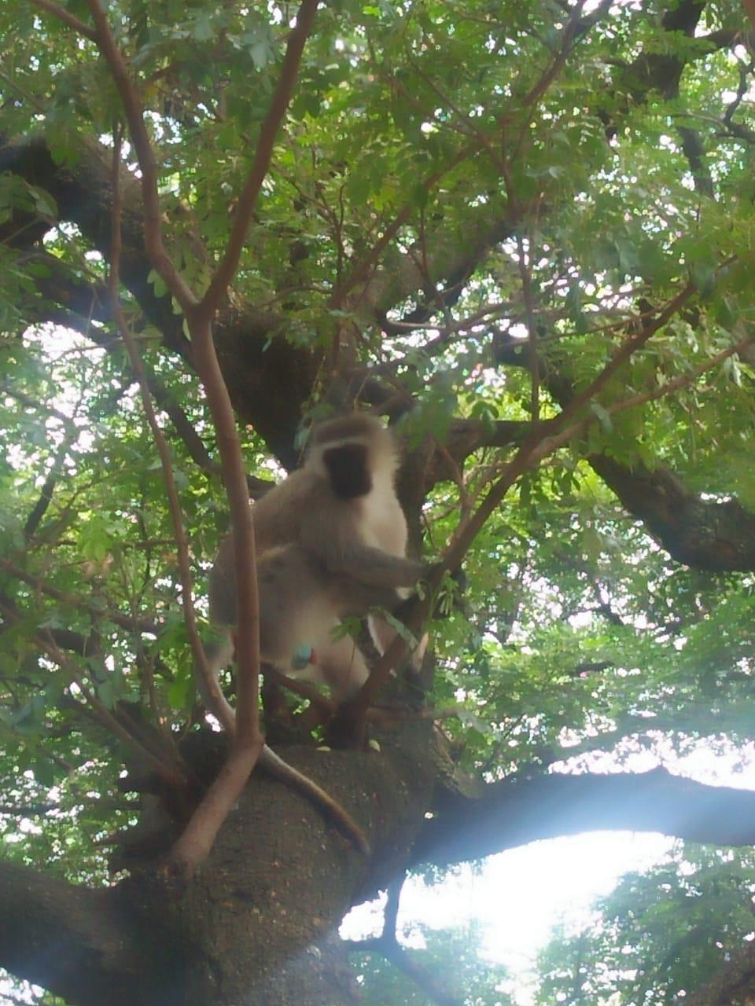
Figure 13. A photo of Cercopithecus chlorocebus in the Cerengoni forest.

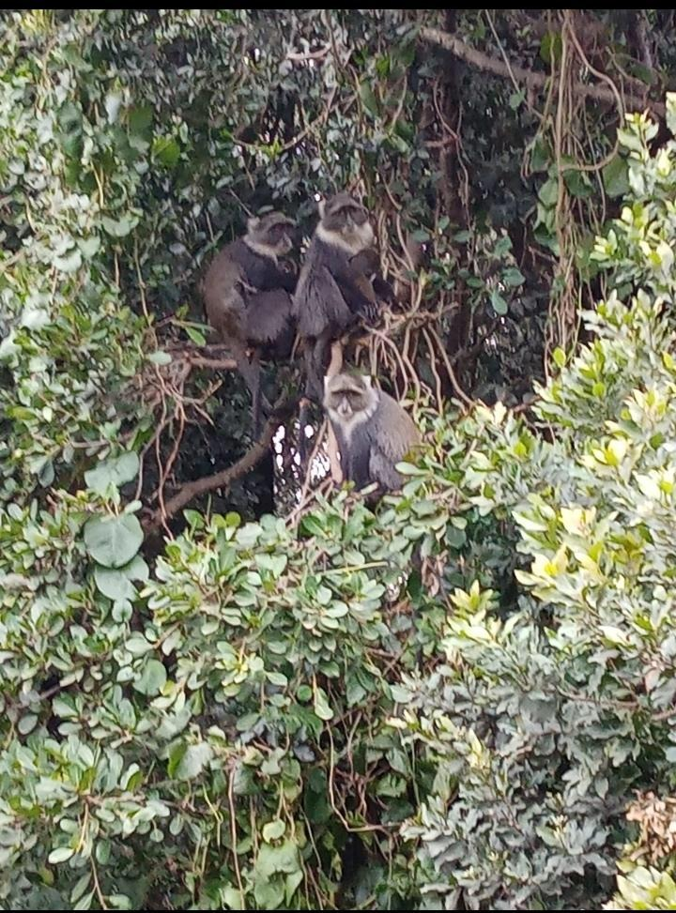
Figure 14. A photo of Cercopithecus albogularis in the Cerengoni forest.
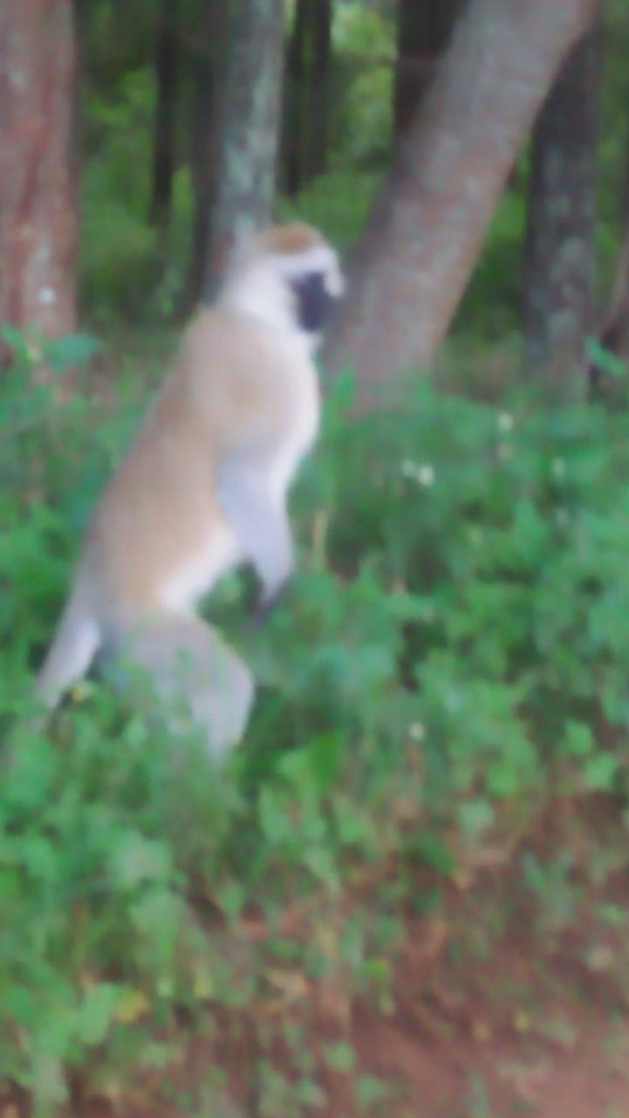

Figure 15. A photo of a Vervet monkey species.

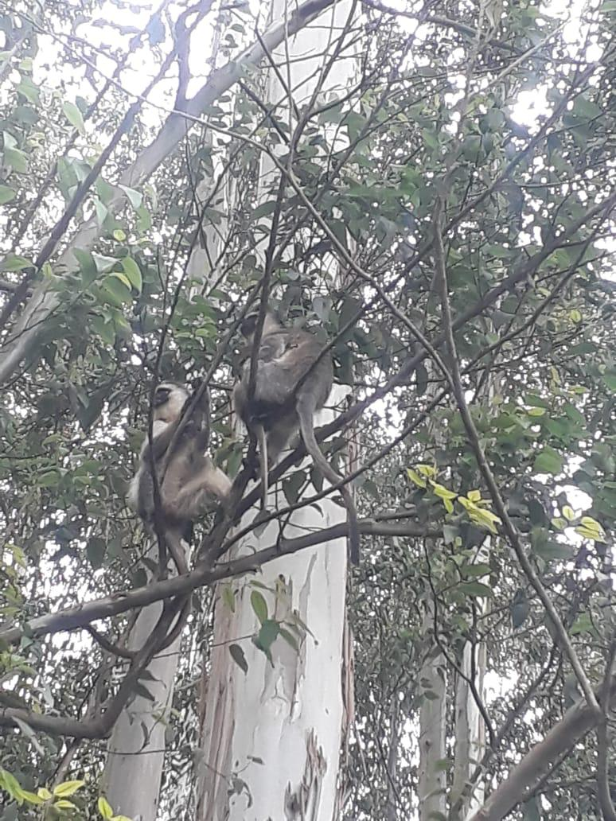
Figure 16. A photo of Sykes monkeys’ species.
Interpretation of Research objective 2. Monkey Species Debarking Cupressus lusitanica and Pinus patula in Cerengoni and Discussion.
Due to increasing habitat loss and degradation, primate populations are living in small fragments isolated by human dominated landscapes (Marsh, 2003; Cowlishaw and Dunbar, 2000; Onderdonk and Chapman, 2000; Mekonnen et al., 2012). Even today, many primates tend to occur in relatively small forest blocks (Cowlishaw and Dunbar, 2000). Based on this study observation from the photos below, it shows the monkey species that debark Pinus patula were the Vervet monkeys and Cupressus lusitanica were debarked by Sykes monkeys in Cerengoni. (Bitetti, 2019) in his studies, recorded on bark stripping trees whereby three of the three primates; the chacma baboon (Papio ursinus), the black capuchin monkey (Sapajus nigritus), and the Sykes monkeys (Cercopithecus albogularis), were the ones responsible for most of the damage reported in large scale plantations and this affected the Pinus patula plantations. There were fewer reports found in the damage by vervets (Chlorocebus aethiops) in the pine plantations in Malawi, and Zimbabwe.

Interpretation of Research objective 3. Estimated Losses Due to Debarking of Cupressus lusitanica and Pinus patula and Discussion.
From the findings of the study, there was a higher percentage of debarking especially in Cupresssus lusitanica. Long-term losses were thus incurred as a result of this. Mutiso et al., (2008), in a study carried out in the Mt Kenya ecosystem, it is likely that C. lusitanica is one of the fallback resources. These monkeys were found to prefer the barks of this species. Prevalence of debarking and its associated effects pose a threat to major plantations in the Mt. Kenya ecosystem. Surveys were undertaken in 2008 at Mt Kenya Ecosystem to evaluate the prevalence and cause of monkey debarking across the age cohorts of C. lusitanica. From the present studies findings, there were no previous studies carried out in this forest region of specific these two compartments. When Cupressus tree species were debarked, the tree died completely. This is a clear indication that the whole forest goes into a loss because useful trees of importance effects to the environment are lost. As in the case of Pinus patula, where at least when debarking occurs, the tree heals and regenerates. From the findings of Fashing (2004), the debarked parts of the tree not only provide entry points to the destructive particles, but also adversely affect the tree growth. Debarking predisposes stems that have been affected to a wide range of destruction, secondary infections, and damage. Cerengoni forest station had 73% of the sampled trees debarked which is a higher incident of debarking by the monkeys. This high incidence of debarking is evidence that the monkeys are under pressure on their diet base where the lack of nutrients in the surrounding environment contribute to the shift in their feeding habit. Evidence is clear that debarking by these monkey species has greatly affected Cerengoni forest in Nandi County and it is in for a greater risk of losing its only species left in this forest. From the collected samples of trees, the biggest percentage is the one which has been affected more than once. Even though the healing rate is much higher especially in the Pinus patula species, an action has to be taken in order to save the remaining few species of trees from debarking in this forest. The USDA guide for forest service and UNO points out that debarking contributes to bole damage and decay. The disturbance of the habitat and availability of food are major factors which helps in determining the abundance of monkeys, evidence for their importance is uneven.

CHAPTER FIVE

SUMMARY, CONCLUSIONS, AND

RECOMMENDATIONS

Summary
Debarking at the Cerengoni was distributed all over the forest, of both indigenous and planted/exotic trees. Troops of monkeys were observed moving throughout the forest in all the compartments. Monkeys thus debark trees in all the compartments at Cerengoni forest. Cupressus lusitanica and Pinus patula tree bark form a major source of food for monkeys thus they are attracted into the forest to utilize this food resource. It is also evident that they get shelter from the forest vegetation from the fluctuating climatic condition and exposed habitat. Cerengoni 1A of Pinus patula forest compartments recorded 31.9% debarking rate whereas Cerengoni 2G of Cupressus lusitanica recorded 72.8%. This stated therefore, that Cupressus tree species tend to experience almost daily debarking activities which caused severe deterioration to the entire tree species plantation and the chance of these tree species to recover was void. From this study, it was found out that the sykes monkeys (Cercopithecus albogularis), preferred to debark the Cupressus lusitanica species maybe this could be because of the resin content found inside the bark of these trees. This agrees well with (Giesen, 2015), where he stated that resin can serve as a scent trigger that draws singes to trees. Since there were no human anthropogenic activities, regeneration took place in both Cupressus lusitanica and Pinus patula plantations. This main aim of the study was focused on elucidating information and knowledge on debarking by monkeys and their effect on forest ecosystem in Cerengoni forest in Nandi County, Kenya. The findings on debarking showed that, out of the sampled trees, there is a range of debarking experienced by both the Vervet and the Sykes monkey species. Less than 50% of trees are debarked in the Pinus patula plantation and more than 50% of trees are debarked by monkeys in the Cupressus lusitanica plantations.
The study found out that the vervet monkeys, specifically the (Cercopithecus chloricebus) debarked Pinus patula tree species in Cerengoni 1A, while the sykes monkeys (Cercopithecus albogularis) debarked Cupressus lusitanica 2G tree species of the two sub-compartments forest blocks. There was a huge percentage debarking on Cupressus species as compared to that of Pinus patula. The reason for this was that, the bark of the trees of Cupressus species were attractive to the monkeys and as they debarked them, the trees were damaged completely hence resulting to death as compared to the trees of Pinus whereas when debarking occurred, the tree healed.
The study also found out that debarking of trees in Cerengoni forest station, starts from removal of the circumference of the bark to breaking of branches this is mostly seen in Cupressus species and healing of the trees that is specifically the Pinus species. Debarking was extensively and it occurred throughout the entire two sub compartments forests and as a result of these, the two species tree types incurred major losses leading to the loss of these trees specifically the Cupressus and in terms of productivity growth, the trees were rendered not useful. There was no recorded data nor any previous studies done on debarking on these trees hence this study came up with recommendations and ways to mitigate these debarking activities in this forest.

Conclusions
- Monkeys debark both C. lusitanica and P. patula trees in Cerengoni forest at a rate of 73% and 32%, respectively, leading to damage of trees such as breaking of branches, removal of ring and killing of crown. The most prevalent type of debarking in Cerengoni is class 6 which implies that the debarked trees are healing. This is followed closely by class 1 which implies that less than 50% of the circumference of the bark is removed. Class 5 also was prevalent implying that branches of the debarked trees were broken. Based on the results of the study concerning the height of debarking, it can be concluded that the prevalent debarking in Cerengoni forest station was higher than 3 meters.
- Based on the age of debarking, the pictures in the study showed that P. patula had old debarking while C. lusitanica showed both new and old debarking. This concluded that the P. patula of Cerengoni were debarked while still young and hence grew as the debarking heals while C. lusitanica in Cerengoni is debarked at any age. With the help of research assistants, villagers and observation made, the study can conclude that Vervet monkeys (Chlorocebus pygerythrus) and Sykes monkeys (Cercopithecus albogularis) are the monkey species that debark P. patula and C. lusitanica in Cerengoni forest respectively, and cause damage to these trees. My study did not provide any data on the programs for controlling the monkey’s activities in the forest. The present condition does not provide any form of control therefore, this poses a danger to the existing trees in the forest. The scarcity of detailed information on the monkeys also, is evidence of imperative understanding of the monkey’s population in order to exercise effective control measures.
- Objective 3 was not achieved because of lack of first-hand data from the KFS Nandi County Cerengoni offices. No losses of trees could be quantified hence this objective lies in the gap of research studies for future studies. If one of our central aims as conservation biologists, is the prevention of species decline and loss (Sodhi and Ehrlich, 2010; Soulé, 1985) surely, there is much support for the need to be proactive. Perhaps, it is that the environmental impacts of common species are so obvious that they are too easily overlooked. Declines in widespread and abundant species can be incremental rather than one acute incident. And perhaps as humans, we are more adept at perceiving complete loss rather than gradual declines in populations (Pain et al., 2008). This lack of perception of gradual change in an environmental feature is problematic due to the severity of nonlinearity of the relationship between population size and range size, later declines can be extremely rapid (Gaston, 2011). Therefore, we need to improve our ability to detect threats to common species as well as changes in trajectories of abundance and contractions in distributions (Linden Mayer et al., 2011). We must rectify the disparity in conservation focus to a more balanced approach, rather than the focus we now have on rarity and extinction. We need to broaden conservation to include valuing common species, and maintaining abundance (Gaston, 2011; Redford, Berger and Zack, 2013).
- The hypothesis of this study found out that the mean diameter of debarked trees, is not the same for Cupressus lusitanica and Pinus patula. This is evident in the One- test sample statistical t- test carried out as shown in tables 4 and 2 above. Also, the mean height of debarked trees is not the same for Cupressus lusianica and Pinus patula. This is evident from the One- Sample statistical t- test on DBH Heights carried out as shown on tables 7 and 8 respectively.

Recommendations
- It will be of great importance for the forest management to carry out a routine survey to obtain and keep data on the monkey debarking. This will help to obtain financial losses experienced due to monkey debarking. What has been established in this study is that, there is no information of this kind and it would thus appear that the extent of monkey debarking is exaggerated and losses are not quite severe.
- The Kenya’s forest management most specifically, the Kenya Forestry Service Nandi County, should identify different techniques in the battle against monkeys debarking, and the general commitment to primate survival strategies in Cerengoni Forest.
- A similar study to be done on other forests within Nandi County and Kenya as a whole, on other tree species to help confirm the results of this study.
- The principle of prevention states that; “the protection of forests is best achieved by preventing harm in the first place, rather than relying on remedies or compensation for such harm after it has occurred”. This principle is important to sustainable forestry management, especially given the speed of forest destruction and the length of time for regeneration. A good example of this is Cerengoni forest. If a survey had been previously conducted on these two tree species concerning the debarking occurrence by these monkeys, an alternative solution would have been taken and prevented the loss of these tree species type.
- The food and Agriculture Organization of the United Nations defines participatory forestry as the processes and mechanisms that enable those people who have a direct stake in forest resources to be part of decision making in all aspects of forest management, from managing resources to all aspects of formulating and implementing legal frameworks.

Recommendation for Further Research
- The Forests Acts is relied on to provide the main legal strategies employed by Kenyan law to ensure sustainable management and conservation of Kenya’s forests. This Act offers guidance and identifies the various stakeholders who are involved in the conservation of forests in Kenya. It creates the Kenya Forest Service and empowers it to manage and conserve forests in Kenya. It provides for the various techniques of conservation and establishes standards on the accepted conduct in relation to forests and sets out the penalties in the event of any breach of the Act. Since objective three of this study was not achieved, for future studies therefore, one needs to compute the percentage of trees drying/dying due to debarking then get the estimated selling price per tree, and calculate the estimated loss for the compartments, and afterwards, project it for the whole forest that is if the forest is under any authorization to sell any of their tree’s species to the public.

REFERENCES
Ahmadi, K., Alavi, S.J., Kouchaksaraei, M.T. and Aertsen, W. (2013). Non-linear height-diameter models for oriental beech (Fagus orientalis Lipsky) in the Hyrcanian forests, Iran. Biotechnol. Agron. Soc. Environ. J., 17, 431–440.
Althof, A. J. (2005). Human impact on flora and vegetation of Kakamega Forest, Kenya.
Altmann, S. A. and Altmann, J. (2010). Baboon Ecology-African Field Research. Bbliotheca Primatologica, (12), 1.
Asner, G.P., David, K., Paulo, B., Michael, K. and Jose S. (2005). Selective logging in the Brazilian Amazon Science 310: 410-482.
Barnett, J. L., How, R. A., and Humphreys, W. F. (2007). Possum damage to pine plantations in north-eastern New South Wales. Australian Forest Research, 7(3), 185-195.
Bayat, M., Namiranian, M., Zobeiri, M., Omid, M. and Pukkala, T. (2014). Growth and yield models for uneven–aged and mixed broadleaf forest (Case study: Gorazbon District in Kheyroud Forest, North of Iran). Iran. J. For. Poplar Res. 22, 39–50.
Bekele, T. (1993). Vegetation ecology of remnant Afromontane forests on the central plateau of Shewa, Ethiopia. Sv. växtgeografiska sällsk.
Beeson, M. (2007). The origins of bark-stripping by blue monkeys (Cercopithecus mitis): Implications for management. Zoological journal of the Linnean Society, 91(3), 265-291.
Ben-Shahar R. (1998). Elephant density and impact on Kalahari woodland habitats. Transactions of the Royal Society of Southern Africa, 53 (2):149-155.
Bigalke, R. C. and Van Hensbergen, H. J. (2010). Baboon damage in plantation forestry in South Africa. South African Forestry Journal, 152 (1), 26-33.
Bigalke, R. C. and Van Hensbergen, H. J. (1990). Baboon damage in plantation forestry in South Africa. South African Forestry Journal, 152 (1), 26-33.
Calenge, C., D., Maillard, J.M., Gaillard, L. Marlot and R. Peltier. (2002). Elephant damage to trees of woodland savanna in Zakouma National Park, Chad. Journal of Tropical Ecology 18: 599- 614.
Castella, P. R., Britez, R. M. and Mikich, S. B. (2004). Áreas prioritárias de Floresta com Araucária para conservação no estado do Paraná. In Curitiba, Anais do IV Congresso Brasileiro de Unidades de Conservação (Vol. 718, pp. 1677-1486).
Chazdon, R.L. (2008). Chance and determinism in tropical forest succession. In Tropical Forest community ecology. Wiley-Blackwell, Oxford, UK.
Chapman, C. A., Chapman, L. J. and Wrangham, R. W. (2005). Ecological constraints on group size: an analysis of spider monkey and chimpanzee subgroups. Behavioral Ecology and Sociobiology, 36(1), 59-70.
Chapman, C.A. and Peres, C.A. (2001). Primate conservation in the new Millennium: the role of scientists. Issues, News, and Reviews, Evolu Anthrop. 10:16-33.
Chirchir, E., Sudoi, V. and Kimanzi, J. (2018). Impacts of Forest Disturbance on Food Trees of Colobus angolensis in Kibonge Forest, Kenya. Africa Environmental Review Journal, 3(1), 82-93.
Cˆot´e, S.D., Rooney, T.P., Tremblay, J.-P., Dussault, C. and Waller, D.M., (2004). Ecological impacts of deer overabundance. Annu. Rev. Ecol. Evol. Syst. 35 (1), 113–147.
Cowlishaw, G. and Dunbar, R. (2000). Primate Conservation Biology. The University of Chicago Press, Chicago.
Di Bitetti, M. S. (2019). Primates bark-stripping trees in forest plantations–A review. Forest Ecology and Management, 449, 117482.
De Leeuw, J., Njenga, M., Wagner, B. and Iiyama, M. (2014). Treesilience: An as. by: The World Agroforestry Centre (ICRAF), Nairobi, Kenya.
Droomer, E. A. P. (2011). Volume and value loss owing to samango monkey damage in pine stands in the Northern Transvaal. South African Forestry Journal, 134 (1), 47-51.
Duane, E., Susan, D. C. and Harold, F. H. (1997). Elephants: Nutrition and Dietary Husbandry. Fact sheet 004.
Eker, M, Çoban, H.O. and Acar, H.H. (2011). Time study and productivity analysis of chainsaw mounted log debarker in southern pine forests of Turkey. Afr J Agric Res. 6 (10): 2146–2156.
Eubanks, M. D. and Denno, R. F. (1999). The ecological consequences of variation in plants and prey for an omnivorous insect. Ecology, 80(4), 1253-1266.
Evans, J. (1992). Plantation forestry in the tropics: tree planting for industrial, social, environmental, and agroforestry purposes. Oxford University Press.
Ezz, M. A., Marey, M. A., Elweza, A. E., Kawai, T., Heppelmann, M., Pfarrer, C., and Miyamoto, A. (2019). TLR2/4 signaling pathway mediates sperm-induced inflammation in bovine endometrial epithelial cells in vitro. PLoS One, 14(4), 0214516.
F.A.O. (2007). Forest Pest Species Profile: Heteropsyllacubana, Crawford, 1914. Rome: FAO. www.fao.org/forestry/13564-1-0.pdf.
Fashing, P.J. (2002). Population status of black and white colobus monkeys (Colobus guereza) in Kakamega Forest, Kenya: are they really on the decline? Afr Zool. 37: 119-126.
Fashing, P. J. (2004). Mortality trends in the African cherry (Prunus africana) and the implications for colobus monkeys (Colobus guereza) in Kakamega Forest, Kenya. Biological conservation, 120(4), 449-459.
Gaston, K. J. (2011). Common ecology. BioScience, 61(5), 354-362.
Gauthier, N.W., Fountain, W.F. and Missun, T. (2015). Tree wounds-invitations to wood decay fungi. Plant Pathology Fact Sheet. Collage of Agriculture. Food and Environment. University of Kentucky.
Geldenhuys, C.J. and Delvaux, C. (2007). The Pinus patula plantation … a nursery for natural forest seedlings. In: Bester, J.J., Seydack, A.H.W., Vorster, T., Van der Merwe, I.J. & Dzivhani, S. (eds), Multiple use management of natural forests and woodlands: Policy refinement and scientific progress. Proceedings of the Natural Forests and Savanna Woodlands Symposium IV, 15–18 May 2006, Port Elizabeth, South Africa. Pretoria: Department of Water Affairs and Forestry. pp 94–107.
Geldenhuys, C.J., Syampungani, S., Meke, G. and Vermeulen, W.J. (2007). Response of different species on bark harvesting for traditional medicine in Southern Africa. In: Bester, J.J., Seydack, A.H.W., Vorster, T., Van der Merwe, I.J. and Dzivhani, S. (eds), Multiple use management of natural forests and woodlands: policy refinement and scientific progress. Proceedings of the Natural Forests and Savanna Woodlands Symposium IV, 15–18 May 2006, Port Elizabeth, South Africa. Pretoria: Department of Water Affairs and Forestry. pp. 55–62.
Gill, R. M. A. (1992). A review of damage by mammals in north temperate forests: 1. Deer. Forestry: An International Journal of Forest Research, 65(2), 145-169.
Gill, R., Webber, J. and Peace, A. (2000). The economic implications of deer damage. Contract Report, The deer Commission for Scotland.
Goodall, J. (2006). The chimpanzees of Gombe: Patterns of behavior. Cambridge Mass.
Gülci, N., Akay, A.E. and Erdaş O. (2017). Productivity assessment of alternative timber debarking methods. Šumarski List. 9–10:469–476.
Hamilton III, W. J., Buskirk, R. E. and Buskirk, W. H. (2016). Defense of space and resources by chacma (Papio ursinus) baboon troops in an African desert and swamp. Ecology, 57 (6), 1264-1272.
Hansson, L. (2005). Damage by wildlife, especially small rodents, to North American Pinus contorta provenances introduced into Sweden. Canadian Journal of Forest Research, 15 (6), 1167-1171.
Hausfater, G. and Bearce, W. H. (2006). Acacia tree exudates: Their composition and use as a food source by baboons. African Journal of Ecology, 14 (3), 241-243.
Hautier, Y., Tilman, D., Isbell, F., Seabloom, E. W., Borer, E. T. and Reich, P. B. (2015). Anthropogenic environmental changes affect ecosystem stability via biodiversity. Science, 348 (6232), 336-340.
Heppelmann, J. B., Labelle, E. R., Wittkopf, S. and Seeling, U. (2019). In-stand debarking with the use of modified harvesting heads: a potential solution for key challenges in European forestry. European Journal of Forest Research, 138 (6), 1067-1081.
Hiscocks, K. (1999). The impact of an increasing elephant population on the woody vegetation in southern Sabi Sand Wildtuin, South Africa. Koedoe 42, 47–55.
Holdo, R. M., Dudley, J. P. and Mcdowell, L. R. (2002). Geophagy in the African elephant in relation to availability of dietary sodium. Journal of Mammalogy 83: 652–664.
Hou, R., Chapman, C. A., Jay, O., Guo, S., Li, B. and Raubenheimer, D. (2020). Cold and hungry: Combined effects of low temperature and resource scarcity on an edge‐of‐range temperate primate, the golden snub‐nose monkey. Ecography, 43 (11), 1672-1682.
James, D. B. and Clough, M. E. (2011). Baboon damage in relation to fertilization of Pinus radiata at Bergplaas State Forest, Southern Cape. In press. pp8.
Junker, J., van Arde, R. and Ferriera, S. (2008). Temporal trends in Elephant (Loxodonta africana) numbers and densities in Northern Botswana: Is the population really increasing? Oryx, Vol. 42, No. 1, pp 58-65.
Katerere, Y. (2012). Aphid density and animal damage to Pinus patula Schiede and Deppe in a clone bank at Melsetter forest research station. South African Forestry Journal, 122(1), 63-65.
Kingdon, J. and Largen, M. J. (1997). The kingdom field guide to African mammals. Zoological Journal of the Linnean Society, 120 (4), 479.
Klopp, J. M. (2012). Deforestation and democratization: patronage, politics and forests in Kenya. Journal of Eastern African Studies, 6 (2), 351-370.
Lindenmayer, D. B., Wood, J. T., McBurney, L., Mac Gregor, C., Youngentob, K., and Banks, S. C. (2011). How to make a common species rare: A case against conservation complacency. Biological Conservation, 144 (5), 1663-1672.
Lock, J. M. (2012). Baboons feeding on Euphorbia candelabrum. African Journal of Ecology, 10 (1), 73-76.
Lombard, A.T., Johnson, C.F., Cowling R.M. and Pressey, R.L. (2001). Protecting plants from elephants. Botanical reserve scenarios within the Addo Elephant National Park, South Africa. Biol. Conserv. 102, 191-203.
Longonje, S. and Kosgey, K. (2007). Bark stripping of Celtis africana by red Colobus monkey, Colobus badius tephrosceles in Kibale National Park, Uganda. Wildlife Conservation Society, Cameroon, Thursday.
Maganga, S. L. S. and Wright, R. G. (1991). Bark‐stripping by blue monkeys in a Tanzanian forest plantation. International Journal of Pest Management, 37 (2), 169-174.
Mallo, M., Wellik, D. M. and Deschamps, J. (2010). Hox genes and regional patterning of the vertebrate body plan. Developmental Biology, 344, 7–15.
Marsh, G. P. (2003). Man, and nature. University of Washington Press.
Matiru, V. (1999). Forest cover and forest reserves in Kenya: Policy and practice. IUCN, Nairobi.
McNally, J. (2015). Damage to Victorian exotic pine plantations by native animals. Australian Forestry, 19 (2), 87-99.
McNamara, L. M. (2005). Nutrient concentration of inner bark tissue in pine trees in Mpumalanga in relation to baboon damage (Doctoral dissertation, University of the Witwatersrand).
Mekonnen, M. M. and Hoekstra, A. Y. (2012). A global assessment of the water footprint of farm animal products. Ecosystems, 15 (3), 401-415.
Metslaid, M., K¨oster, K., Jogiste, K., Randveer, T., Voolma, K. and Moser, W.K. (2013). The effect of simulated bark stripping by moose on scots pine height growth: An experimental treatment. Balt. For. 19 (1), 61–66.
Midgley, J. (2011). Massive mortality of tree euphorbias and tree aloes in Baviaanskloof. Afr. Wlidl., 45(1): 36 - 38.
Mikich, S. B., and Liebsch, D. (2014). Damage to forest plantations by tufted capuchins (Sapajus nigritus): Too many monkeys or not enough fruits? Forest Ecology and Management, 314, 9-16.
Mikich, S. B. and Liebsch, D. (2014). Assessment of food supplementation and surveillance as techniques to reduce damage caused by black capuchin monkeys Sapajus nigritus to forest plantations. Current Zoology, 60 (5), 581-590.
Mittermeier, R.A., Valladares-Padua, C., Rylands, A.B., Eudey, A.A., Butynski, T.M., Ganzhorn, J.U., Kormos, R., Aguiar, J.M. and Walker, S. (2006). Primates in peril: The world’s 25 most endangered primates 2004–2006. Prim. Conserv. 20, 1–28.
Mligo, C., Lyaruu, H., Ndangalasi, H. and Marchant, R. (2009). Vegetation Community Structure, Composition and Distribution Pattern in the Zaraninge Forest, Bagamoyo District, Tanzania. Jounal of East African Natural History. 98:223– 239.
Myers, N., Mittermeier, R. A., Mittermeier, C. G., Da Fonseca, G. A., and Kent, J. (2000). Biodiversity hotspots for conservation priorities. Nature, 403(6772), 853-858.
Mutiso, F (2007). Applicability of Selected Sampling Designs to Forest Health Assessment: The Case of Kakamega Moist Tropical and Mt Elgon Montane Forests. M.Phil Thesis, Department of Forestry and Wood Science, Moi University, Eldoret, November 1.
Nishida, T. (2006). The bark-eating habits in primates, with special reference to their status in the diet of wild chimpanzees. Folia primatologica, 25(4), 277-287.
Okama,J. I. and Chamshama, S. A. 0. (1988). Thinning of Cupressus lusitanica on Mount Meru, Northern Tanzania. Tanzania Journal of Science 14: 145-154.
Omar, A. and De Vos, A. (2010). Damage to exotic softwoods by Sykes monkeys (Cercopithecus mitis kolbi Neuman). East African Agricultural and Forestry Journal, 35(4), 323-330.
Özçelik, R., Diamantopoulou, M.J., Crecente-Campo, F. and Eler, U. (2013). Estimating Crimean juniper tree height using nonlinear regression and artiﬁcial neural network models. For. Ecol. Manag. 306, 52–60.
Pach, M. (2008). Tempo zarastania spał na jodle oraz niekt´ore czynniki na nie wpływające. Sylwan 152 (4), 46–57.
Page, B.R. (1995). Predicting the impact of elephants on communities of woody plants in Elephant Management and Owners Association. Proceeds of a workshop on the management of the African elephant. Aventura Resort, Warmbaths 3 and 4 November.
Pedreira, P. A., Penon, E. and Borgnia, M. (2017). Bark stripping caused by the introduced squirrel Callosciurus erythraeus (Sciuridae) in Argentina. Bosque, 38 (2), 415-420.
Redford, K. H., Berger, J. and Zack, S. (2013). Abundance as a conservation value. Oryx, 47 (2), 157-158.
Reinecke, S. A. and Reinecke, A. J. (2007). The impact of organophosphate pesticides in orchards on earthworms in the Western Cape, South Africa. Ecotoxicology and environmental safety, 66 (2), 244-251.
Ribeiro, M. C., Metzger, J. P., Martensen, A. C., Ponzoni, F. J. and Hirota, M. M. (2009). The Brazilian Atlantic Forest: How much is left, and how is the remaining forest distributed? Implications for conservation. Biological conservation, 142(6), 1141-1153.
Ross, F.J. (2004). Blamed for Destroying One of North Africa’s Most Important Forests, Morocco’s Barbary macaques Struggle to Survive.
Sala, O.E., Stuart, F.C., Armesto, J.J., Berlow, E., Bloomfield, J. and Dirzo, R. (2005). Global biodiversity sceneries for the year 2100. Science 287:1770-1774.
Scowcroft, P. G. and Sakai, H. F. (2004). Stripping of Acacia koa bark by rats on Hawaii and Maui.
Seifert, T., Seifert, S., Seydack, A., Durrheim, G. and Von Gadow, K. (2014). Competition effects in an afro temperate forest. Forest Ecosystems, 1(1), 1-15.
Sellin, A., Rohejarv, A. and Rahi, M. (2008). Distribution of vessel size, vessel density and xylem conducting efficiency within a crown of silver birch (Betula pendula). Trees-Structure and Function, 22, 205-216.
Shannon, D. M. (2000). Using SPSS (R) To Solve Statistical Problems: A Self-Instruction Guide. Prentice-Hall, Inc., One Lake St., Upper Saddle River, NJ 07458.
Shorten, M. O. N. I. C. A. (2013). Damage caused by squirrels in Forestry Commission areas, 1954–6. Forestry, 30 (2), 151-151.
Skarpe, C., P. A. Aarrestad, H. P. Andreassen, S. S. Dhillion, T. Dimakatso, J. T. duToit, D. J. Halley, H. Hytteborn, S. Makhabu, M. Mari, W. Marokane, G. Masunga, D. Modise, S. R. Moe, R. Mojaphoko, D. Mosugelo, S. Motsumi, G. Neo-Mahupeleng, M. Ramotadima, L. Rutina, L. Sechele, T. B. Sejoe, S. Stokke, J. E. Swenson, C. Taolo, M. Vandewalle, and P. Wegge. (2004). The return of the giants: Ecological effects of an increasing elephant population. Ambio 33:276–282.
Sodhi, N. S., and Ehrlich, P. R. (Eds.). (2010). Conservation biology for all. Oxford University Press.
Soulé, M. E. (1985). What is conservation biology? BioScience, 35(11), 727-734.
Steinheim, G., Wegge, P., Fjellstad, J.I., Jnawali, S.R. and Weladji, R.B. (2005). Dry season diets and habitat use of sympatric Asian elephants (Elephas maximus) and greater one-horned rhinoceros (Rhinoceros unicornis) in Nepal. Journal of Zoology 265:377-385.
Stoltz, L.P. and Saayman, G. (1970). Ecology and behaviour of baboons in the northern Transvaal. Annals of the transvaal museum, 26 (5), 99-143.
Styles, C.V. and Skinner, J.D. (2000). The influence of large mammalian herbivores on growth form and utilization of mopane trees, Colophospermum mopane. African Journal of Ecology. 38:95-101.
Sulevan, T. P. and Sullivan, D. S. (2011). Barking damage by snowshoe hares and red squirrels in lodgepole pine stands in central British Columbia. Canadian Journal of Forest Research, 12 (2), 443-448.
Tesfaye, M. A., Gardi, O., Anbessa, T. B. and Blaser, J. (2020). Aboveground biomass, growth and yield for some selected introduced tree species, namely Cupressus lusitanica, Eucalyptus saligna, and Pinus patula in Central Highlands of Ethiopia. Journal of Ecology and Environment, 44(1), 1-18.
Thanh, T.N., Tien, T.D., Shen, H.L. (2019). Height-diameter relationship for Pinus koraiensis in Mengjiagang Forest Farm of Northeast China using nonlinear regressions and artiﬁcial neural network models. J. For. Sci. 65, 134–143.
U.N.O. (United Nations Organization) Conservation and Management of Closed Forest (1994): A Manual of Field Techniques for Students and Trainees. UNO/RAF/006/GEF. E, A. Forest Field Workshop, Uganda, Pp. 177.
U.S.D.A. Forest Service (2000) Forest Inventory and Analysis International Core Field Guide. Field Data Collection Procedures for Phase 2 Plots. Volume 1, Version 1.5, Pp. 68-86.
Vacek, Z., Cukor, J., Linda, R., Vacek, S., Simůnek, V., Brichta, J., Gallo, J., Prokůpkov´a, A., (2020). Bark stripping, the crucial factor affecting stem rot development and timber production of Norway spruce forests in Central Europe. For. Ecol. Manage. 474, 118360.
van Aarde, R. J., T. P. Jackson, and S. M. Ferreira. (2006). Conservation science and elephant management in southern Africa. South Africa Journal of Science 102:385 388.
Varma, S., Dang, N.X., Thanh, T.V. and Sukumar, R. (2008).The elephants Elephas maximus of Cat Tien National Park, Vietnam: status and conservation of a vanishing population. Oryx, Vol. 42 (1): 92-99.
Vasiliauskas, R., Stenlid, J. and Johansson, M. (1996). Fungi in bark peeling wounds of Picea abies in central Sweden. Eur. J. For. Pathol. 26 (6), 285–296.
Vasiliauskas, R. and Stenlid, J. (1998). Fungi inhabiting stems of Picea abies in a managed stand in Lithuania. For. Ecol. Manage. 109 (1-3), 119–126.
Vermeulen W.J. (2009). The sustainable harvesting of non-timber forest products from natural forests in the southern Cape, South Africa: development of harvest systems and management prescriptions, PhD dissertation, Department of Conservation Ecology and Entomology, Stellenbosch University, South Africa.
Vieira, G.C., De Mendonça, A.R., Da Silva, G.F., Zanetti, S.S., Da Silva, M.M. and Dos Santos, A.R. (2018). Prognoses of diameter and height of trees of eucalyptus using artiﬁcial intelligence. Sci. Total Environ. 619, 1473–1481.
Von dem Bussche, G. H. and Van der Zee, D. (2005). Damage by samango monkeys, Cercopithecus (mitis) albogularis, to pine trees in the Northern Transvaal. South African Forestry Journal, 133 (1), 43-48.
Wermelinger, B. (2006). Ecology and Management of Spruce Bark Breetle Ips typographus- A Review of Recent Research. Swiss Federal Institute for Forest, Snow and Landscape Research WSL, Zurichstrasse 111, Birmensdorf Ch-8903, Switzerland.
Western, D. (2006). A half century of habitat change in Amboseli National Park, Kenya. African Journal of Ecology 45:302–310.
Williams, V. L., Witkowski, E. T. F. and Balkwill, K. (2007). Relationship between bark thickness and diameter at breast height for six tree species used medicinally in South Africa. South African Journal of Botany, 73(3), 449-465.
Wormald, T.J. (1975). Pinus patula. Tropical Forestry Papers!: 41-42.
Worton, B. J. (1989). Kernel methods for estimating the utilization distribution in home‐range studies. Ecology, 70 (1), 164-168.
Xiong, B.M., Wang, Z.X., Li, Z.Q., Zhang, E., Tian, K., Li, T.T. and Li, Z. (2016). Song, C.L. Study on the correlation among age, DBH and tree height of the Pseudotsuga sinensis in Qizimei Mountain Nature Reserve. For. Resour. Manag. 4, 41–46.
Zhao, C., Craig, J. C., Petzold, H. E., Dickerman, A. W. and Beers, E. P. (2005). The xylem and phloem transcriptomes from secondary tissues of the Arabidopsis root-hypocotyl. Plant Physiology, 138 (2), 803-818.
Zhou, R., Wu, D., Fang, L., Xu, A. and Lou, X. (2018). A Levenberg–Marquardt backpropagation neural network for predicting forest growing stock based on the least-squares equation fitting parameters. Forests, 9 (12), 757.
Zhou, R., Wu, D., Zhou, R., Fang, L., Zheng, X. and Lou, X. (2019). Estimation of DBH at Forest Stand Level Based on Multi-Parameters and Generalized Regression Neural Network. Forests, 10, 778.

APPENDICES

APPENDIX A: OTHER FEATURES IDENTIFIED IN CERENGONI FOREST

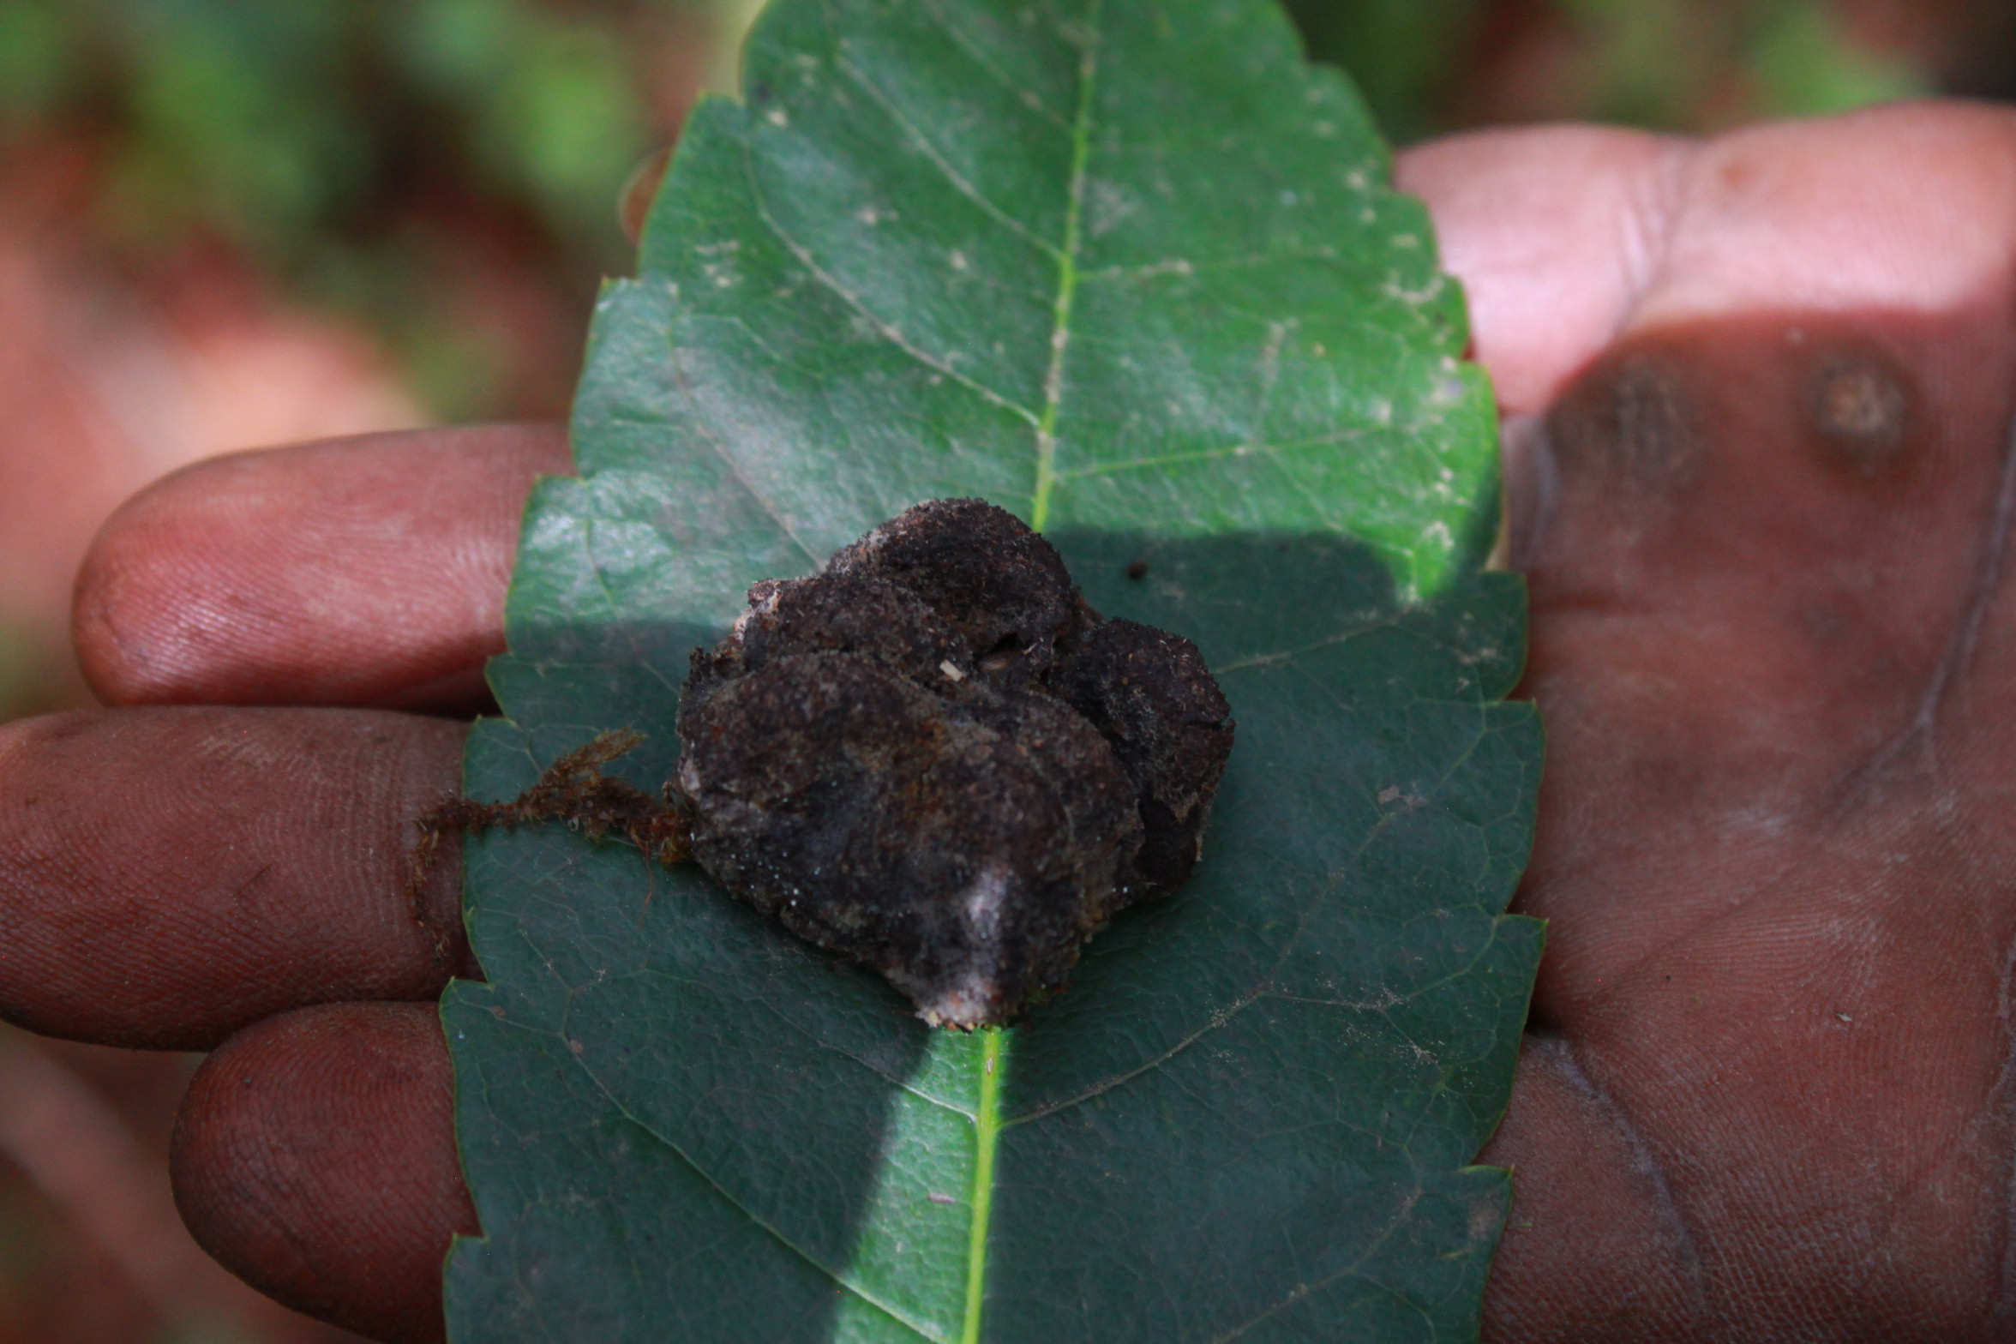
Figure 17. Fecal matter of Cercopithecus Chlorocebus.
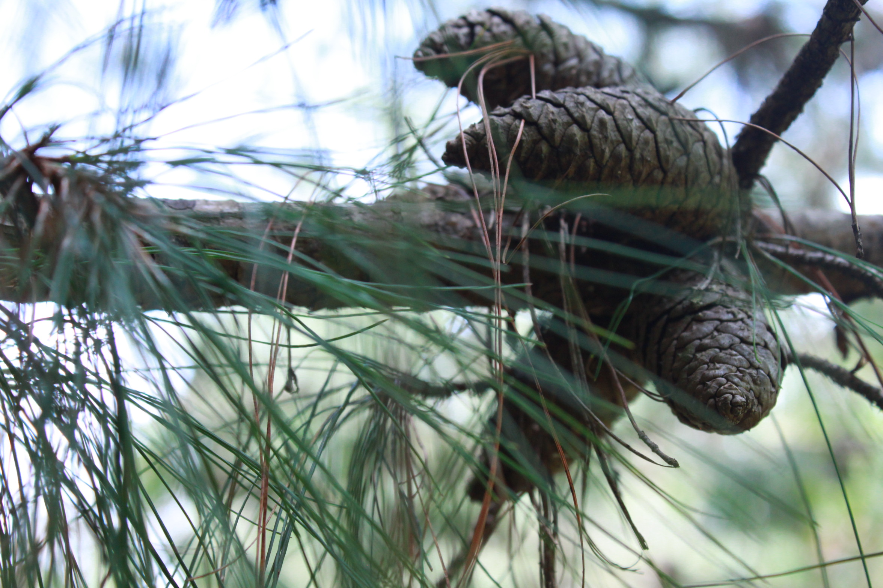
Figure 18. A mature seed of a Pinus patula tree.

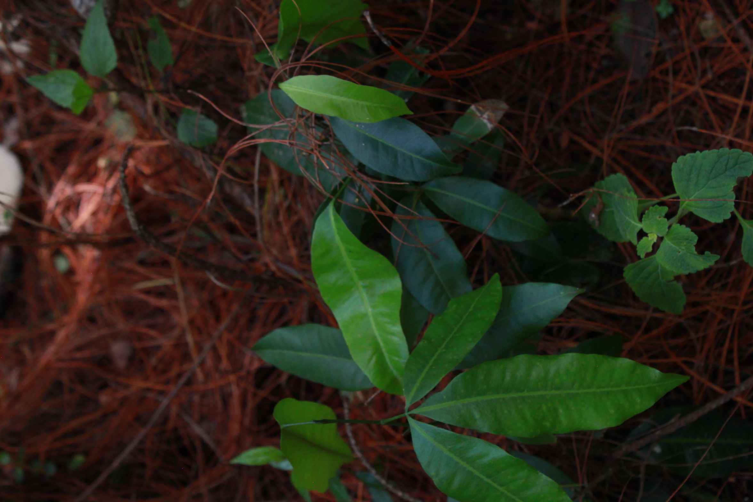
Figure 19. Magnifera indica.
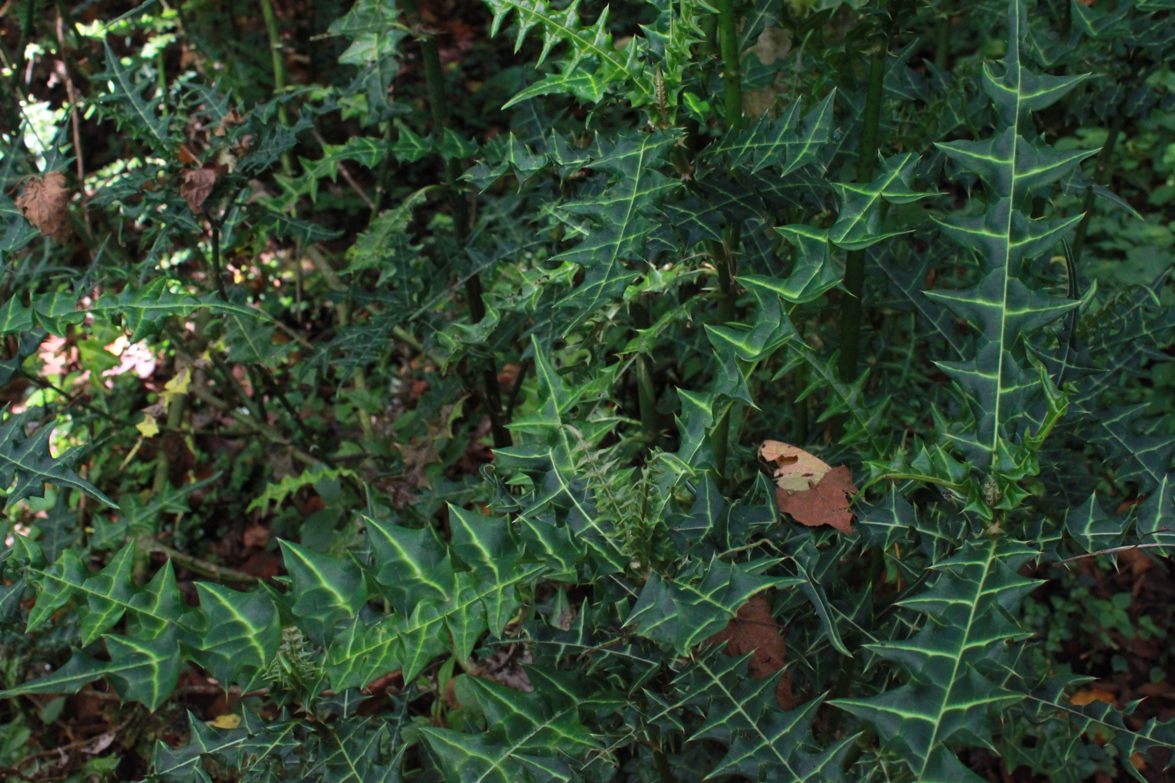
Figure 20. Acanthus polystachyus.

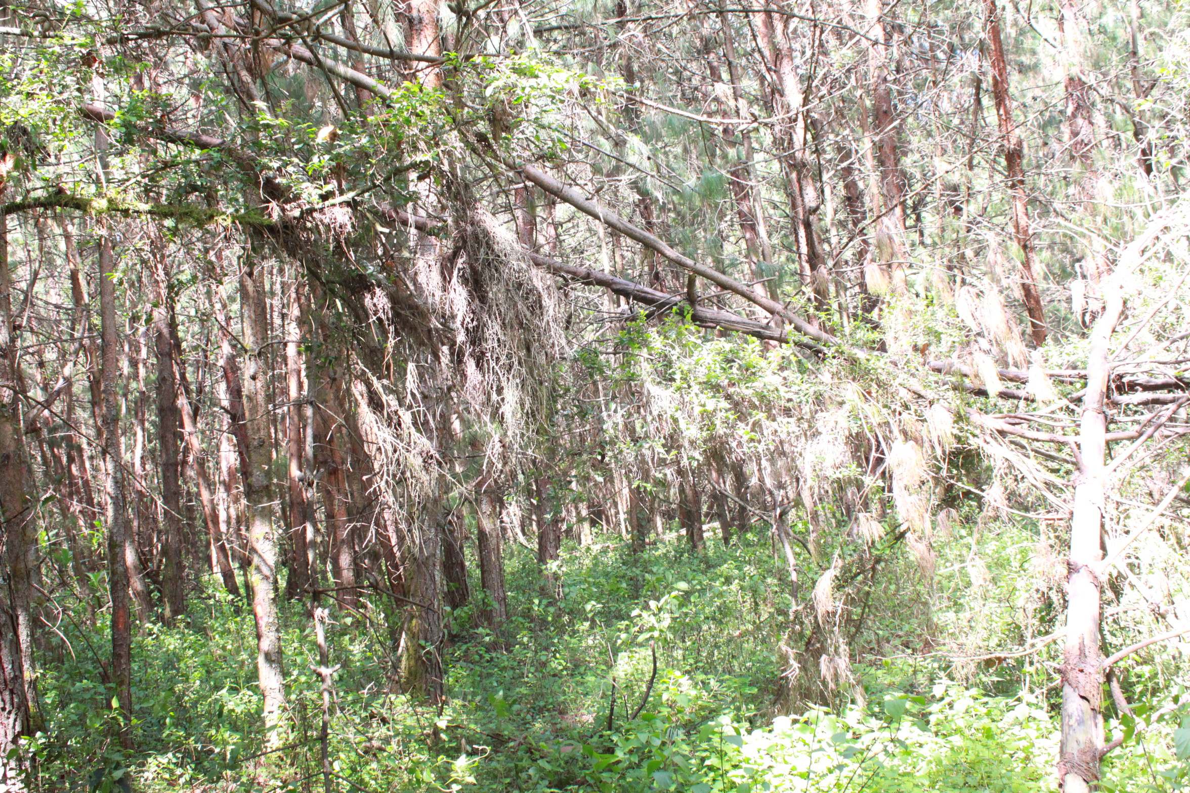
Figure 21. Cerengoni forest showing trees falling as a result of extensive debarking.

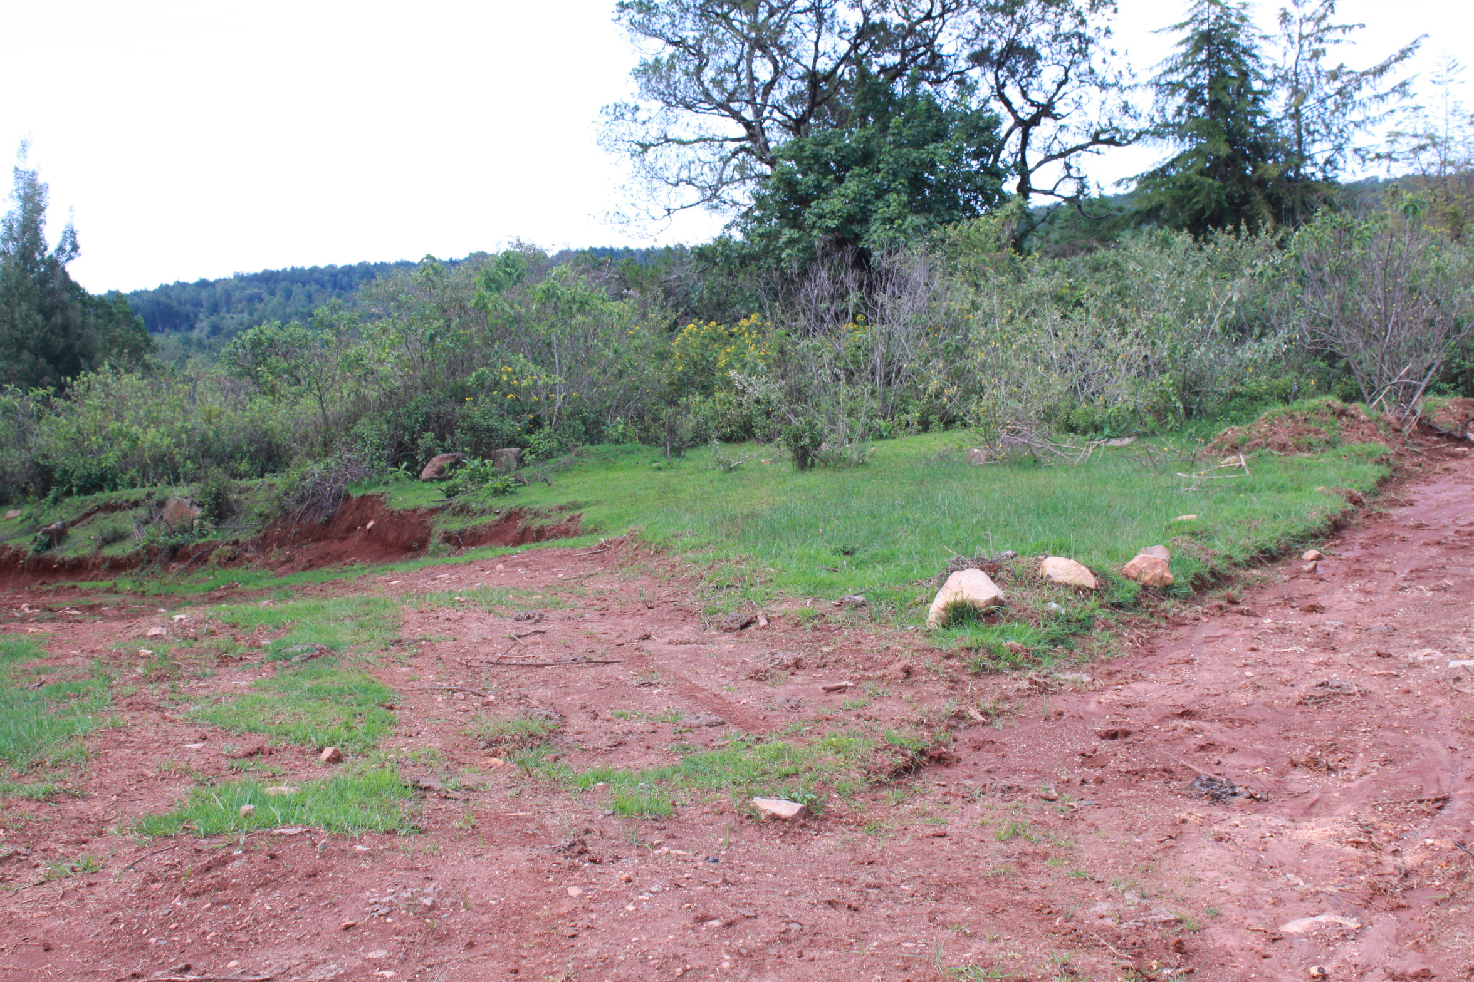
Figure 22. Shrubs, herbs and some few standing trees outside the forest area of Cerengoni.

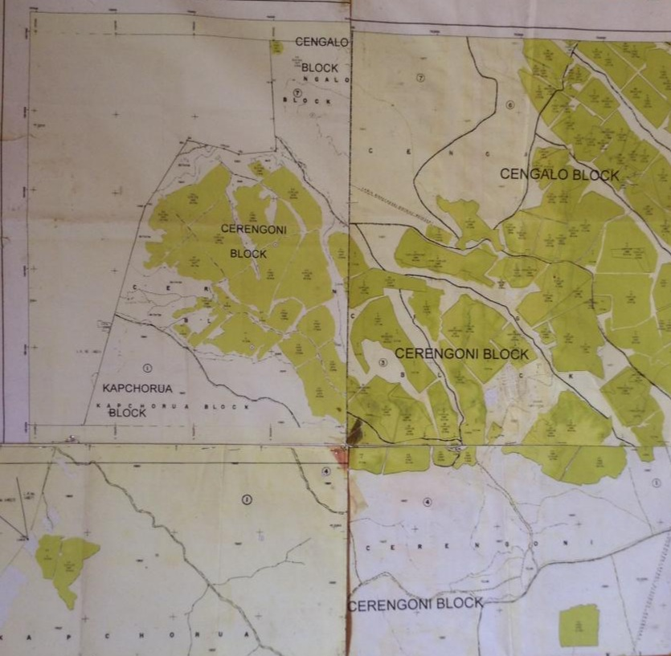
Figure 23. Map showing Cerengoni block in Cerengoni Forest.

APPENDIX B. RESEARCH TIMETABLE
Period  Task | 2019 | 2020 | 2021 |  |  |  |  |  |  |  |  |  |  |  | 2022
Period  Task | Dec | Dec | Jan | Feb | March | Apr | May | Jun | July | Aug | Sep | Oct | Nov | Dec | March | April | June
Concept Presentation
Pre-Visit to The Study Site
Proposal Presentation
Field Work
Data Analysis and Thesis Writing
Thesis Publishing
Submission of Thesis Work
Pre-Defense Assignments
- Corrections of the Thesis Work
- Endorsement Form Signing
- Academic Clearance
- Consultation Form Signing
Thesis Defense
Post- Thesis Defense Corrections
Final Submission of Thesis

APPENDIX C. ETHICAL CLEARANCE
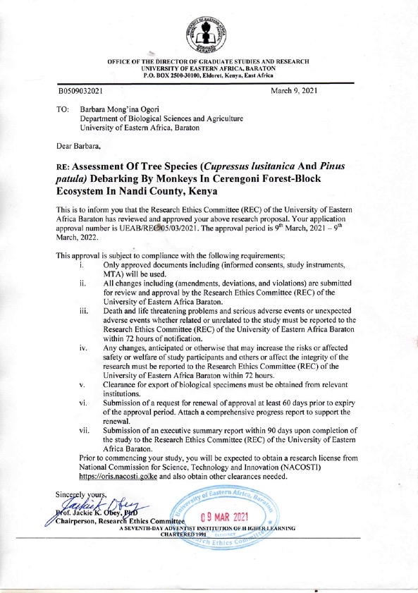
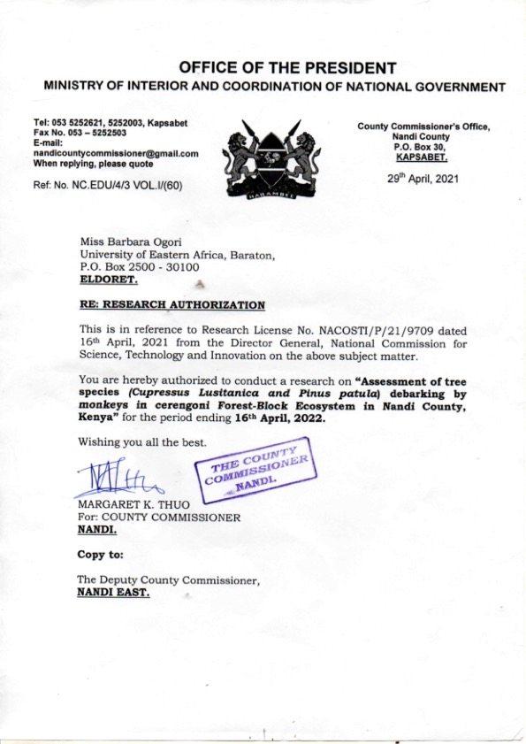

APPENDIX D. BUDGET
ITEM ACTIVITY | UNIT COST (Ksh) | TOTAL (Ksh)
Travelling Cost to the Study Site (Car Hire) for 4 months | 1,500Ksh for each of the 3 days= 4,500Ksh  4,500 for each of the 3 weeks monthly= 13,500Ksh  13,500Ksh for the 4 months | 54,000Ksh
Renumeration of 3 Research Assistants for 4 months. Each gets 1,500 per day. For 3 weeks. | 1,500Ksh per day, 3 days in a week for 3 weeks monthly | 54,000Ksh
 |  | 108,000Ksh
EQUIPMENTS
ITEMS
Suunto Clinometer | 1,500 (1) | 1,500
Diameter Tape | 3,900 (1) | 3,900
Linear Tape | 7,000 (1) | 7,000
GPS carmen model | 30,000 (1) | 30,000
Radio Tracking device (rented out) for 4 months. Each month @10,000Ksh | 40,000 (1) | 40,000
Mammal Field Study Guide Book | 900 (1) | 900
Axe | 750 (1) | 750
20 Plastic Bags each @ 20 | 400 | 400
Camera EOS Rebel SL3 Canon | 70,000 (1) | 70,000
3 pkts of Ziploc Bags. Each pkt has 25 pieces @20 | 500 | 500
Manila Rope 200mm (200*35) | 7,000 (1) | 7,000
 |  | 161,050Ksh
STATIONERY
Foolscaps (Ruled) 4reams | 400 | 1,600
Photocopying papers 7 reams | 400 | 2,800
Document Holder 5 pcs | 100 | 500
Ball pen 10pcs | 20 | 200
 |  | 5,100Ksh
SECRETARIAL SERVICES
Proposal typing 32pgs | 20 | 640
Proposal photocopying 320 pages | 3 | 960
Proposal binding 3 copies | 350 | 1050
Thesis photocopying 800pgs | 3 | 2400
Thesis binding 8 copies | 300 | 2,400
Contingency |  | 10,000
 |  | 17,450Ksh
PUBLISHING FEES
Standard Publication fees (105 +14 transfer fees+119USD) $119.00USD  Equivalent to 13,685Ksh | 1 Paper | 13,685Ksh

KSH 306,185

APPENDIX E. CURRICULUM VITAE
PERSONAL DETAILS:
Barbara Mong’ina Ogori
P.O. Box 60537-00200
NAIROBI, KENYA
Email: barbaraogori@gmail.com
TEL: +254 722309184

CAREER VISION: Work towards restoration, conservation and promotion of environmental biodiversity.
CAREER COMPETENCIES:
My career competencies are summed up as follows;
Professionalism: I always endeavor to apply transparency and accountability in my work ethics as I ensure that I observe deadlines towards achieving better results.
Planning and Organizing: In every task I ensure that I develop clear objectives which are consistent with any given work strategy. This is I do so by setting aside appropriate amount of time, and resources, for my work completion driven with focus on priority activities/tasks.
Teamwork: I am alive to the fact that all working environment entails working together with your colleagues to accomplish the goals and dreams of the organization. I strongly believe and respect others’ ideas and expertise.

PERSONAL PROFILE
Barbara is a Masters student in science specializing in Conservation Biology of specific, Biodiversity Management. She has pursued her bachelors of science in Conservation Biology from the University of Eastern Africa Baraton. She has a deep focus in Conservation of Biodiversity. It is in no doubt her integrity and commitment in her career is highly demonstrated on how diligent, hardworking, and experienced she has been as an environmental conservationist. Suffices to say, Barbara is skilled in Research and Environmental Education, Conservation Issues, Biodiversity and Sustainability.

ACADEMIC ACHIEVEMENTS
Barbara has published her academic thesis article in the International Journal Sciences: Basic and Applied Research (IJSBAR).
https://www.gssrr.org/index.php/JournalOfBasicAndApplied/article/view/13411/6197
My published thesis article work is also available on ResearchGate as https://www.researchgate.net/publication/35730048_Assessment_of_Tree_Species_Cupressus_lusitanica_and_Pinus_patula_Debarking_by_Monkeys_in_Cerengoni_Forest-_Block_Ecosystem_in_Nandi_County_Kenya

ACADEMIC QUALIFICATIONS
2018-2022: Masters of Science in Conservation Biology from University of Eastern Africa Baraton
2009-2013: Bachelor of Science Degree in Conservation Biology from University of Eastern Africa Baraton.

WORK EXPERIENCE
2021 October- Present: Researcher fellow- Nature Kenya
Duties/Responsibilities
- Visitations to various wetlands in Kenya to promote environmental education and conservation awareness through the Nature Kenya Youth Committee.
2018 August- 2021 August: Project Student Researcher- Cerengoni Forest, Nandi County- Kenya Forestry Service
- I specialized in the Conservation of Biodiversity management, working on a research project of monkeys and their debarking effects on exotic trees species in Nandi East Forest, Kenya.
Duties/Responsibilities
- Assessing exotic trees of Cupressus lusitanica and Pinus patula at Cerengoni Forest forest block ecosystem Kenya
- Monitoring debarking activities by monkeys at Cerengoni Forest blosk ecosystem Kenya
2016 January- June 2018: Student Researcher- National Museums of Kenya, Zoology Department, Ichthyology sections
Duties/Responsibilities
- Supervision on field expeditions
- Public awareness on conservation of wetlands and biodiversity management
- Laboratory taxonomical work on fish species
- Database management
- Carried out research scientific reports and writings of both zoological and botanical taxa
2015 March - October 2015: Intern - National Environment Management Authority (NEMA) Kenya
I worked at the department of Enforcement and Compliance- field operations,
Duties/Responsibilities
- Process and issuance of various licenses to clients
- Review and classification of environmental impact assessment reports (EIA) and environmental audit reports (EA)
- Registration and investigation of environmental incidences
- Report writing
- Offer customer services to clients with various environmental incidences, sharing knowledge about NEMA, and issuance of customer feedback forms
- Carried out field inspections.
2014 October - November 2014: Intern - Ministry of Environment, Water and Natural Resources (Kisii County) Kenya
I worked at the department of Environment.
Duties/Responsibilities
- Assisted in office report writing on environmental matters
- Research and scientific writing on Eucalyptus tree species rehabilitation and Bamboo tree species
- Awareness creation and education of the importance of Bamboo species to the communities around Kisii environments.
2014 May- August 2014: Directors' Executive - African Forest Company
I worked as a botanist in four different projects conducted at the Forest. Planet positive forestry, sustainable efficient bio- charcoal production, sustainable agricultural techniques, and, production facilities and markets for non-timber forest products (NTFP's).
2013 June- January 2014: Intern - National Museums of Kenya, Nairobi (NMK)
I worked at department of Zoology, Herpetology and Ichthyology sections specializing in the research of snakes and fish species also as a laboratory assistant (part-time)
Duties/Responsibilities
- Carried out database management
- Performed taxonomical work on fish and snake species
- Facilitated laboratory work on the care and management, and preservation of fish and snake species
- Conducted education awareness on fish and snakes through zoological exhibitions.
2013 January- April 2013: Industrial Attachment- National Environmental Management Authority (NEMA)
I worked at the department of Environmental Impact Assessment and Environmental Audit.
Duties/Responsibilities
- Developed and maintained drafting comprehensive report on the plans of environmental impact assessment and environmental audit
- Assisted NEMA and NOU to gain accurate and detailed picture of environmental sector.

ACADEMIC WRITINGS
- Masters Thesis: ASSESSMENT OF TREE SPECIES (Cupressus lusitanica and Pinus patula) DEBARKING BY MONKEYS IN CERENGONI FOREST-BLOCK ECOSYSTEM IN NANDI COUNTY, KENYA.
- Undergraduate Dissertation: ANTIMICROBIAL EFFECTS OF NEEM LEAVES EXTRACTS (Azadirachta Indica) IN TREATMENT OF URINARY TRACT INFECTIONS (UTI) IN WOMEN AT BARATON VICINITY.

PERSONAL SKILLS
- Good communication skills in both oral and written English
- Proficient in Microsoft tools, database management, and data analysis
- Ability to perform multiple tasks efficiently
- Ability to offer good customer services skills at the same time, I depict kindness and cheerfulness
- Good listening skills
- Able to work in a team-based environment with minimum supervision
- Able to work adhering to professional ethics while promoting transparency and accountability
- Research and analyze reports demonstrating interest and good knowledge in my field area of work
- Ability to interpret in deaf sign language

HOBBIES
- Exploring nature to study environmental conservation
- Swimming
- Watching National Geographic

MEMBERSHIP
- Nature Kenya Society
- Nature Kenya Youth Committee
- Nature Kenya Mammal Commitee
- Samaki Working Group - Kenya
- Kenya Wetlands Biodiversity Research Team (KENWEB)

AWARDS
2022 May: I was awarded a Certificate of participation and Presentation for the 8th Annual Baraton International Interdisciplinary Research Conference held at the University of Eastern Africa, Baraton.
2013 September: I received an award for " Biodiversity and Phylogenetics Capacity Building in Fish Biodiversity, Kenya Project through Tulane University (New Orleans), University of Nairobi, and National Museums of Kenya".
2008 April: I was awarded a Certificate for Computer modules courses from the Institute of Advanced Technology (IAT).

REFEREES
- Prof. Ramesh Francis, PhD
Graduate School Director
University of Eastern Africa, Baraton
P.O. Box 2500-30100
ELDORET- KENYA
Tel: +254775093042
Email: rameshf@ueab.ac.ke

- Dr. Paul Wahonya, PhD
Ag. DVC Academics and Senior Lecturer
University of Eastern Africa Baraton
P.O. Box 2500-30100
ELDORET- KENYA
Tel: +254725496005
Email: wahonyap@ueab.ac.ke
- Mr. Michaiah Ojunga, MSc
Lecturer Department of Biological Sciences
University of Eastern Africa Baraton
P.O. Box 2500-30100
ELDORET- KENYA
Tel: +254713052062
Email: Mojungaf@yahoo.com

- Mr. Oloo Vincent Ochieng’, MSc
County Director of Marsabit
National Environment Management Authority (NEMA)
P.O. Box 204-6050
MARSABIT- KENYA
Tel: +254712302367
Email: yussufochieng@nema.go.ke yussufochieng@gmail.com
APPENDIX F: PLAGIARISM CERTIFICATE

APPENDIX G: PUBLICATION

